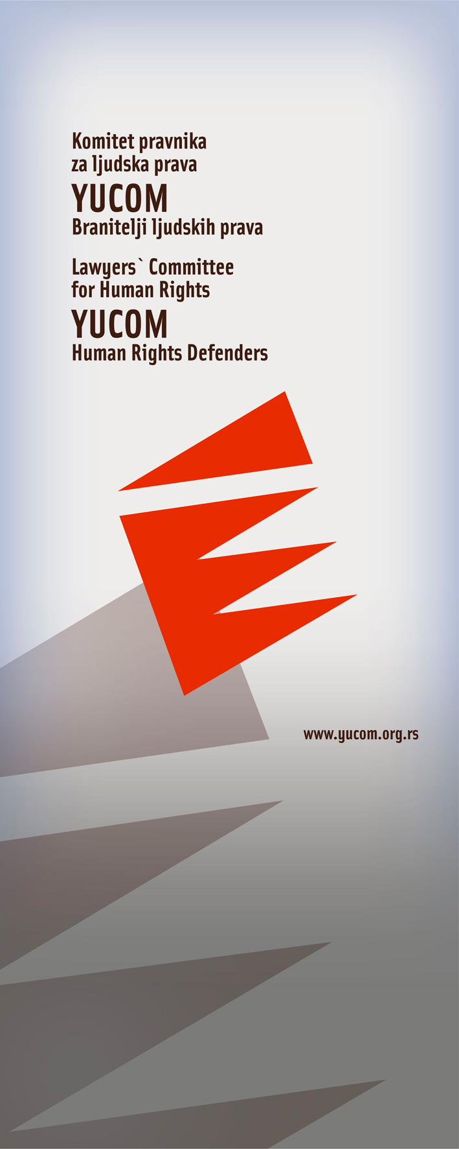

BULLETIN
OFFICE OF LEGAL AID

April 2011

Lawyers’ Committee for Human Rights
Svetogorska 17
11 000 Beograd

Call center for legal aid

0 700 400 700



Bulletin of the project “Legal aid in cases of violation of human Rights, discrimination and protection of human rights defenders”, implemented by YUCOM with the support and the cooperation of the non governmental organization Civil Rights Defenders

The Right to Protection of Identity Information

Facts about the subject:

The Appelate Court of Užice initiated the case against minor S. Ž. of Roma nationality, due to the criminal act of „Inciting national, racial and religious hatred and intolerance.”

He is suspected of writing out graffiti with messages of racistic content directed towards Roma people, as well as painting swastikas in a Roma colony in Požega in the night between 13th and 14th of January this year.

The Lawyers’ Committee for Human Rights recognized this case as indicative in terms of human rights, especially regarding minority rights and the rights of juvenile offenders, hence the Committee took over the litigation of the case.

Also, it was observed that in the proceedings against juvenile offenders there has been a constant violation of the provisions of the Penal Law of the Republic of Serbia, as well as the regulation of the Law of minor executers of criminal acts and a criminal-legal protection of minors, relevant to the revelation of the identity of the minor, as well as other important information about the proceeding.

Specifically in this proceeding that has just been initiated, a text has been published in a daily newspapers BLIC. The text has been published on March 30th 2011 under the title ‘’A minor Rom wrote racist messages.” It was stated that the police, after two and a half months, shed some light on the case.

By making such statement, the legal security guaranteed by the constitution (article 3. section 34. of the Constitution of the Republic of Serbia – presumption of innosence) has been violated in the most severe way.

In addition to that, section 55 of the Law of minor executers of criminal acts and a criminal-legal protection of minors has been violated. In this section, it is decidedly stated:

’’Nor the progress of a penal procedure of a minor neither the decision made at the end of that procedure may be announced without the permission of the court.’’

In relation to all the listed facts, the right to protection of identity information has been violated, which is established both by the Constitution of the Republic of Serbia and the special law.

YUCOM’s reaction:

YUCOM addressed the Ministry of Interior of the Republic of Serbia – the Sector of interior control of the police, with the request to re-examine the work of the interior organs, given that they provided media with false information about the minor and the progress of the proceeding, which did not fall under the scope of their authority. In addition to that, we addressed the Commissioner for the protection of the information of public importance and protection of identity information, demanding of him to take measures within his jurisdiction to protect the interests of a minor.

The right to a fair trial and right to respect for private and family life

Facts about the subject

Before the First Basic Court in Belgrade, in January of 2010, the case of a marriage divorce and assignment of the custody of a juvenile child has been initiated. The case was initiated by the mother of the child and at the same time the father of the child initiated the same procedure in his country of residence.
At that time, the custody of the child was assigned to the father, by the decision of the foreign court (All three members of the family have a dual citizenship).

Given that the Centre for Social Welfare did not create the report nor the opinion (because the mother refused to cooperate), despite many cautions and fines issued by the court, the father’s attorneys addressed the Lawyers’ Committee for Human Rights, as the basis for the decision of the competent court. They addressed the Committee with the request for the engagement in the process, since the systematic errors and misconduct in the process were the same as in the case of V.A.M. against Serbia, which YUCOM successfully led before the European Court of Human Rights in Strasbourg.

After the decision to suspend the proceeding was made by a foreign court, due to the lack of jurisdiction, the mother arrived in Belgrade and took the child from the school he attended, without the knowledge of the father and without a lawful order of a court or other competent authority. Until then, the mother did not cooperate with the services in charge, nor responded to any of the calls of the guardianship authorities. By doing so, she was deliberately obstructing the process, disabling the work of both the Centre for Social Welfare and the court.

YUCOM’s Reaction:

Lawyers’ Committee for Human Rights addressed a letter to the Ministry of Labour and Social Affairs, with the request to, in accordance with their duty, carry out its right to supervise the work of the Centre for Social Welfare, with the aim of enabling the Centre to produce findings and opinions, so that the Court accordingly could continue the proceedings.

Meanwhile, the mother reported to the Safe House, referring to the alleged violence. We must be careful because the official documents clearly point to a different conclusion (there is no procedure for protection against domestic violence, nor any other decision that would prove these allegations).

For more than two months, the father did not know where the child was, because the mother did not inform any competent Centre for social work of the child’s wherabouts- what was required of her. To date, the child does not attend school, has no contact with his father, which, thus, means a breach of the fundamental rights of the child - the right to education, and the right to personal relationships with the parent with whom the child does not live.

This is just one of the indicators that might suggest abuse of the institutions in the fight against violence.

Following his address to the competent Ministry, came a reply that in executed right of supervision it had been deducted that the competent guardianship authority had made a series of failures, and that he had missed the deadline for proceeding.

Rather than look at the case from the point of all the facts and conduct of the parties, the Centre for Social Work produced, at the request of the Ministry and in an accelerated procedure a report and an opinion, siding itself with the mother, even though all previous documents and the initial findings and opinion of the father and of the child point to the legitimacy of a different decision.

This is the case where government authorities in their subsequent decisions give legitimacy to the unlawful taking of a child by a parent who is not the child’s guardian.

Regardless a number of cases the state of Serbia has lost before the European Court of Human Rights concerning the rights to a fair trial and right to family life, and which have demonstrated systemic deficiencies, errors and tardiness at work and lack of coordination and efficient mechanism between all relevant institutions. Such behaviour shows that our judicial system still does not accept or implements European standards in these areas.

Abuse of Official Authorizations

Facts about the case:

S. J., by origin from a place in the interior of Serbia, addressed Lawyers’ Committee for Human Rights with complaints about the work of police officers in this area. In fact, her common-law husband, Z.J., a Roma by ethnicity, was beaten in the market in the middle of last year. Upon this, YUCOM filed a criminal complaint to the Prosecutors Office, for the crime of "endangering security". Since then, due to the serious injuries he suffered and because of fears that the attack could happen again, Z.J. very rarely leaves the house.

According to the latest information from the competent office, criminal charges were not taken into consideration until 15th of April 2011, although the charges were filed on the February 9, 2011.

In mid-April, three members of the police station came at the address of Z.J., stating that neighbors reported a noise coming from their home, and the police had come to investigate the matter.

These statements had distressed Z.J. what resulted in Z.J.’s verbal protest against their conduct, expressing his disappointment with the fact that the report which was filed on his behalf fails to be acted upon, and that upon the alleged noise he made - which according to him is not true – was immediately reacted. His verbal complaints have resulted in officers’ overthrowing him to the ground, despite his decreased mobility, which is the consequence of the previous attack on him, at the town market.

After he was knocked to the ground, all three officers physically attacked Z.J., injuring him again. This behavior, police station officials have justified, as it was "an attack on an official while on official duties." After that, he was towed to the police car, while being beaten, taken to the police station and was given an up to 48 hours detention, although there were no reasons for detention given by the CCRS.

YUCOM’s Reaction:

Shortly after S.J. had notified us on the controversial event, and after we had verbally consulted the ex-officio lawyer, who had been recruited as Z.J.’s defender, we verbally made an intervention at the local police station, so that Z. J. would be released, since there were no reasons for his retention.

Additionally, YUCOM lawyers are engaged as defenders at the proceedings against him due to the alleged crime of "assault on an official in discharge of official duties.”

Regarding the unlawful conduct of police officers, a written complaint to their work was submitted to the Ministry of Interior - the Internal Affairs Division.

In the report of the Council of Europe Commissioner for Human Rights in Serbia - in 2009, it was noted that 'now it seems that allegations of police violence in Serbia, are exceptions rather than the rule."
However, the fact is that it has not yet been eradicated, as evidenced by the increased number of citizens who turn to YUCOM with complaints against the police.
The situation is not alarming, but it requires attention and re-establishment of independent mechanisms of control and a wider front of organizations to monitor and react to violations of human rights.

