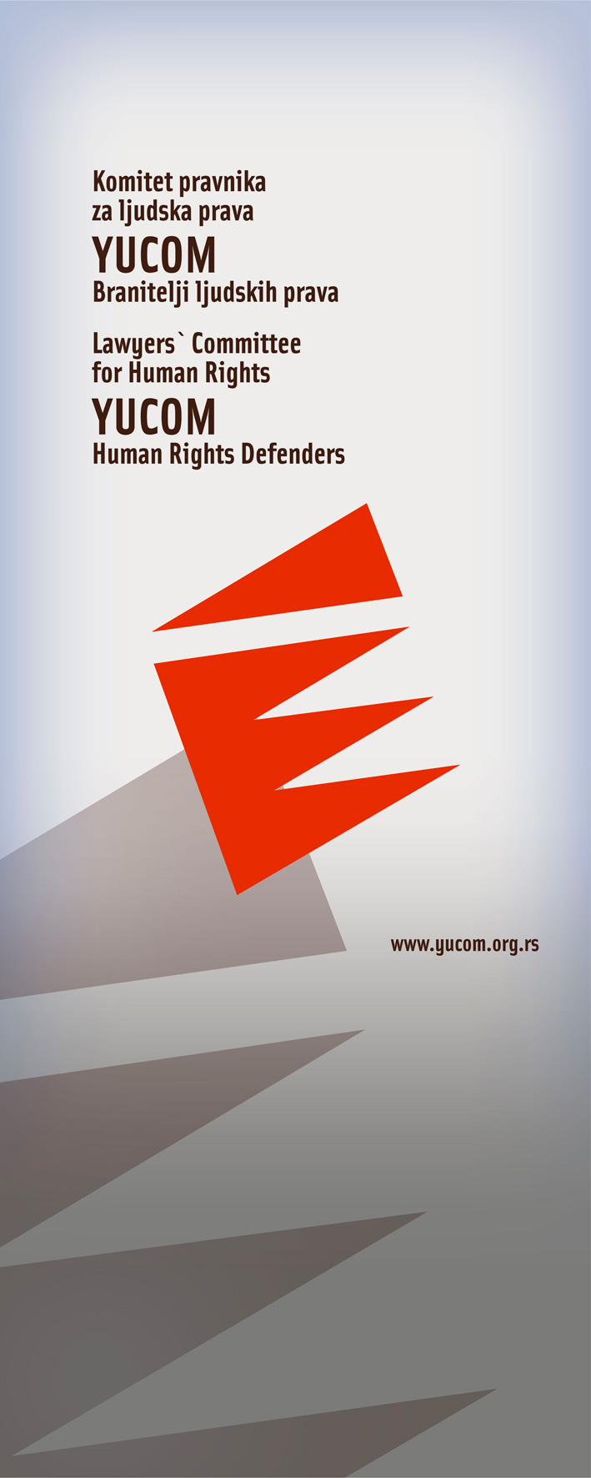

BULLETIN
OFFICE OF LEGAL AID
January – February 2011

Lawyers’ Committee for Human Rights
Svetogorska 17
11 000 Beograd

Call center for legal aid

0 700 400 700



Bulletin of the project “Legal aid in cases of violation of human rights, discrimination and protection of human rights defenders.”, implemented by YUCOM with the support and the cooperation of the non governmental organization Civil Rights Defenders.

The right to a fair trial - trial within a reasonable time - and the right to privacy

The facts of the case:

D.O., from Kragujevac, initiated proceedings for divorce and for protection against domestic violence in 2009. Her husband left the house on August 21st, 2009 and took away with him their child (2.5 months old), without the consent of the wife.
The father was settled in Batocina, and D.O. initiated proceedings with the purpose of being allowed by the judicial authorities to be in contact with her child and to exercise her parental rights. The Center for Social Welfare in Batocina granted a temporary measure to entrust the child to the father. D.O. complained that the contact with the child in Batocina was too brief, and that the conditions for seeing the child were not satisfactory. Indeed, the court granted a temporary measure allowing D.O. to see the child once a week for two hours at the Center for Social Welfare.

Despite the priority of her request, D.O. did everything to be in accordance with the court orders, but she is convinced that the judicial authorities of Serbia kept putting on her a disadvantage and have prevented adequate contacts with her child, which have caused irreparable damages to her family life and to the child’s interests.

The hearings are being constantly postponed. Prolonging the measure could have an effect on the Center for Social Welfare which could give the opinion that the child is attached to his father, even though the father took him away illegally. In so doing, the Centre for Social Welfare proposed an amendment, based on the model of visiting rights, by which the child would go to Kragujevac and have longer contacts with his mother. However, the court did not decide on this proposal for four months.

YUCOM’s reaction:

After YUCOM referred the urgency to the President of the Municipal Court of Kragujevac and to the appointed judge. A temporary measure was issued which significantly extended the contacts between the mother and her child. The court informed YUCOM that after the receipt of the urgency by YUCOM, the temporary measure was issued, and that the violations of the right to family life and the right to a fair trial within a reasonable time were corrected.

It was noted that one of the biggest problems of the domestic judiciary is precisely the violation of the right to a trial within a reasonable time. This is confirmed by the practice of the Constitutional Court of the Republic of Serbia and the European Court of Human Rights (ECHR) since the largest number of the constitutional complaints and petitions submitted to the ECHR applies to the violation of the right to trial.

Case of discrimination against the Roma community

The facts of the case:

In 2010, S.J., Z.L.’s unmarried wife, contacted the Lawyers Committee for Human Rights for help.
S.J., who is a member of the Roma community, explained that she is illiterate and that she can not address the police station of Sremski Mitrovica in writing.
She also pointed out the fact that the officers of the police station of Sremski Mitrovica refused to inform her orally about what happened in the local market where her companion (Y.L., 1972) was beaten by several persons and that she wanted the police station to initiate criminal proceedings, if it was not already done.

YUCOM’s reaction:

The Lawyers Committee for human Rights sent a letter to the police station of Sremska Mitrovica asking if the Police Station filed a criminal complaint against the suspects to the Public Prosecutor Office. YUCOM requested personal information of the suspects and the official records of the event from the Police in order to initiate criminal proceedings.

After a while, YUCOM was informed that the police station of Sremski Mitrovica did not initiate criminal proceeding and that other information could not be disclosed, quoting the Law on the protection of Personal Data. YUCOM filed a criminal complaint to the Basic Public Prosecutor in Sremski Mitrovica for suspected threats against the security of Z.L.

The failure of the authorities of the Police Station of Sremska Mitrovica violates the provisions of the Code of Criminal Procedure, which includes an obligation of all state authorities to report crimes that are prosecuted ex officio, or which are notified or learned in any other way.
Refusing to provide information about the event shows the indifference of the authorities to deal with the general problems of the Roma population, and the discrimination in the proceeding to protect their rights, even in front of the authorities of the Ministry of Interior.

The right to identify documents

The facts of the case:

In the beginning of January 2011, J.D. contacted YUCOM for help, about the failure of the Police Station of Rakovica concerning his request about an ID card.
Indeed, on January 10th, 2011, J.D. filed a request for an issue of biometric ID card in German language, as he is a member of the German Minority group.
The Police station clerk took his application with the necessary documents and after having consulted the head, replied that he would contact him in a few days.

On January 17th, 2011 the head contacted him, indicating that data can be entered in the ID card in latin script, and regarding data entry in two languages - i.e. in minority language in parallel with the Serbian language- , he had to wait for the expert opinion, and told him that he will notify him later.
More than 20 days after the call, he didn’t receive any notification.

YUCOM’s reaction:

YUCOM sent a letter to the competent Ministry of Interior, referring to the relevant provisions of the Law on Identity Cards and the Regulations on Identity Cards, which explicitly states the possibility that records of citizens who belong to a national minority can be issued simultaneously in both languages – Serbian and the language of national minorities.
YUCOM filed appeal that the requested document should be issued in the short term in order to ensure the application of legal provisions.

Article 9 of the law on ID cards states: “The identity card is printed in the language and script of national minorities in accordance with the law.”
Article 17 of the same law states that the deadline for issuing ID cards is 15 days from the date of application.
Failure of the Police Station of Rakovica again showed indifference of the Police to deal with the rights of minority groups, in this case national minorities, as well as backlog of cases coming out of the ordinary “template” procedure.

The respect of the physical and mental integrity and the right to dignity and free development of personality

The facts of the case:

Proceeding for deprivation of legal capacity was initiated against R.N. in front of the court establishment of the Municipal court of Zrenjanin.
The whole proceeding was conducted in contravention with the provisions of the Family Law, (which specified the grounds for depriving a person of the legal capacity), the provisions of the Law on extrajudicial proceedings and the Code of Civil Procedure.
To the person against whom the proceeding have been conducted, the inspection and the copying of the relevant documents of the case was not allowed despite the existence of legal interest.
The proceeding was also conducted in a way which degrades the dignity and violates the principle of equality of arms, in violation of basic human rights, including the right to respect physical and mental integrity, the right to dignity and free development of personality and the right to a fair trial.

YUCOM’s reaction:

Firstly, YUCOM sent a request in order to inspect and copy court records. After the inspection, the deficiencies identified in the initial act and the proposal were submitted to the court asking for a dismissal of the underlying claim as irregular and incomplete or to be rejected as unfunded.
The process is returned to the legal framework, the inequality of the arms was removed and YUCOM expects the court’s decision on the submitted proposal.

Almost every case of psychological violence is inevitably associated with the violation of fundamental human rights as provided by the Constitution of the Republic of Serbia and ratified international treaties. Preventing R.N. to inform herself about the grounds of the procedure against her infringed her right to a fair trial.
It also violated the principle of equality of arms, as part of a fair trial. Unfounded proposals for deprivation of the legal capacity violated the right to dignity and free development of personality, and the possible decision to intern R.N. in a health facility for three months in order to evaluate her ability to be judged, would constitute a flagrant violation of the right to respect physical and mental integrity.

