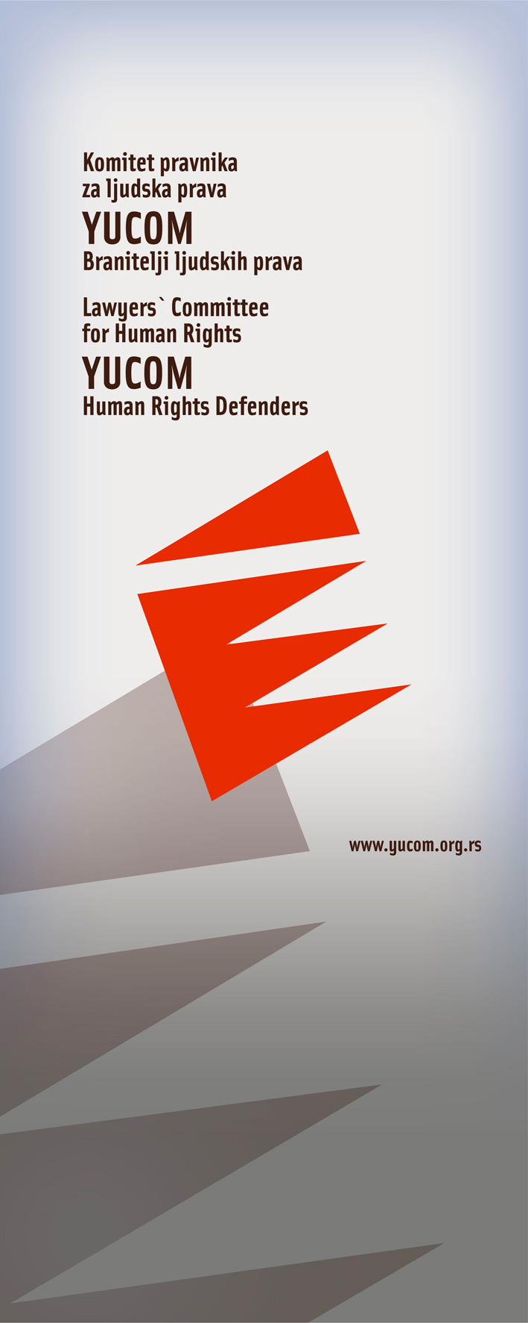

BULLETIN
OFFICE OF LEGAL AID

March 2011

Lawyers’ Committee for Human Rights
Svetogorska 17
11 000 Beograd

Call center for legal aid

0 700 400 700



Bulletin of the project “Legal aid in cases of violation of human Rights, discrimination and protection of human rights defenders”, implemented by YUCOM with the support and the cooperation of the non governmental organization Civil Rights Defenders

During the first three months of 2011, the Office of Legal Aid had 78 new cases. Here is an overview of several most typical cases on which YUCOM reacted.

The right to a fair trial (trial within a reasonable time) and the right to property

The case that we described applies to one of the biggest problems of Serbian judiciary - a violation of the right to trial within a reasonable time. Pointing to such cases, we expect the courts to encourage more efficient practices.
We also emphasize the sensitivity of the issue of the loan for the economic development of Serbia, which marked the beginning of the fraud, looting and impoverishment of the citizens of Serbia during the 90’s.

Facts of the case:
During the 1989 and 1990, Z. M., from Canada, paid the amount of 230,000 Canadian dollars at the expense of Serbia, within the "Loan for the economic development of RS”, in accordance with the Law on Economic Development Loan in the Socialist Republic of Serbia. Z.M. addressed several times the bank with the requirements of debts payment under the contract, since they are heavily penetrated in delay.
After several unsuccessful urging to the bank Z.M. filed a lawsuit in May 2003 before the First Municipal Court of Belgrade, for debt reimbursement.
In the process according to the lawsuit, which is still in progress, numbers of legally unfounded judgments were maid, which were abrogated after appeal of Z.M. by the Appellate Court. The documentary evidence presented by the plaintiff during the hearings were not valued during the adjudication. The representatives of the defendant, who have been duly invited each time, presented themselves only at a few hearings, and despite the abuse of their process authority have never been sanctioned by the Court.

YUCOM’s reaction:

After having obtained the relevant court documents from the plaintiff, the Lawyers’ Committee for Human Rights filed a constitutional appeal before the Constitutional Court of the Republic of Serbia, indicating a violation of these rights by the judicial authorities.
At the moment, the response of the Constitutional Court is expected, and in the case it is not satisfactory, YUCOM will bring the case before the European Court of Human Rights.

Conference on "Combating Violence"

On March 1st 2011, in the Media Centre in Belgrade, YUCOM held a conference on the theme "Combatting violence," within the project "Legal aid in cases of violation of human rights, discrimination and protection of human rights defenders".
The panelists present at the conference were Maja Micic, the director of the Youth Initiative for Human Rights, Danica Jovanovic, representative of the NGO Banat Women's Roma Network, Marija Savic, a representative of the Coalition Against Discrimination, Natalija Solic and Kristina Todorovic, both lawyers at YUCOM, and the director of YUCOM, Milan Antonijevic.
Through the presentation of cases lead by non-governmental organizations, panelists stressed the unduly different approaches of public authorities in the fight against violence against vulnerable groups - Roma, mentally disabled persons, national minorities, women and LGBT population.
One of the themes which were tackled at the conference was the impact of the NGOs in advocacy before government bodies, and the consequences that human rights defenders suffer because of their engagement.
YUCOM also announced the launch of the Call Centre (0700-400-700), for provision of legal assistance to victims of human rights violations.
Summing up the problems that citizens have addressed to YUCOM in the past three months, it was pointed out that largest number of citizens asking for help were representatives of marginalized social groups - members of ethnic minorities, LGBT population and people with mental disabilities.
One of the conclusions of the participants of this conference organized by the Lawyers’ Committee for Human Rights was that civil society must be more active and that there is the need to strengthen cooperation in the fight against violence.

The hate speech case and discrimination against LGBT population

Facts of the case:
In early 2011, in Smederevo, unknown persons drew graffiti containing messages of hatred towards homosexual population and inciting the killing of gay men. The graffiti were written on several major buildings in the center of this town.
Graffiti contain a number of the most severe threats and calls for murder and violence against the citizens of Serbia because of their different sexual orientation, and requires the denial of their constitutionally guaranteed rights, including the right to peaceful and nonviolent assembly and association.
Writing such messages on the walls is clearly a case of open hate speech, as well as expanding and presenting ideas and theories that advocate hatred, discrimination and violence against members of the homosexual population.

Apart from the obvious intention of spreading fear among LGBT people in Serbia, following crimes were committed:
- racial and other discrimination (Article 387 paragraph 2 of the Criminal Code of the Republic of Serbia (CCRS));
-hate speech (Article 11 of the Law on prohibition of discrimination);
-harassment and degrading treatment (Article 12 of the Law on prohibition of discrimination);
- severe form of discrimination (Article 13, paragraph 1 and paragraph 7 of the Law on prohibition of discrimination );
-discrimination based on sexual orientation (Article 21 of the Law on prohibition of discrimination).

YUCOM’s reaction:

YUCOM invited the Commissioner for the protection of equality, to take urgent measures and eliminate these graffiti, and also filed criminal charges against the unknown persons for the crime of racial and other discrimination, provided by the article 387 paragraph 2 of the CCRS.

What is alarming is the lack of adequate responses of relevant state and municipal authorities, especially in a situation when Serbia finally adopted Anti-discrimination Law and when the relations and the degree of tolerance of the majority towards minority groups becomes relevant as an indicator of the willingness of society to join the European process of integration.

Attacks on Human Rights Defenders

Facts of the case:
In March this year, one of the peace activists of the NGO "Women in Black", received more than ten messages at the e-mail address. Each of them was harassing, threatening and highly offensive. In addition to those serious threats, the majority of the messages also contained photos of the same character – vulgar and disturbing.
Thse messages clearly expressed condemnation of advocacy of human rights activists in Serbia for equality among all - regardless of race, religion, sex, sexual orientation or of any other distinction.

Messages are sent from several different e-mail address and few of them directly point to members of right-wing organizations.

YUCOM’s reaction:

YUCOM filed criminal charges for racial and other discrimination to the Prosecutor's office, according to the Article 387 paragraph 2 of the Criminal Code of RS as well as for the violent behaviour, according to the Article 344 of the CCRS. YUCOM requested from the Ministry of Interior to collect all the necessary information on persons who committed the offence through the Department for High-tech criminal, via their e- mail / IP address, in order to enable investigation proceedings.

Threats against the Roma family in Jabuka and offence of endangering safety

Facts of the case:
In February 2011, the Prosecutor’s office initiated criminal proceeding against A.S., for the crime of endangering safety, according to the Article 138 paragraph 2 of the CCRS.

Under the indictment of OJT's, from Pancevo, A.S. was charged because in July 2010 she sent text messages, via a mobile phone, containing a grave threat to life and safety of the family of a minor B.J., who is from the village of Jabuka, near Pancevo. In a first instance, by the verdict of the High Court of Pancevo, B.J. was sentenced to four years of imprisonment in a juvenile prison, for the murder of one of his peers, D.S.

YUCOM’s reaction :

The Lawyers’ Committee for Human Rights decided to represent the plaintiffs, the family of the minor B.J.

At the hearing on March 3^{rd,} 2011, both parties were interrogated and process of presenting evidence was terminated. The trial was held in presence of representatives of the Regional Minority Centre and Women in Black.

On the same day, the first instance verdict was made, by which A.S. was conditionally sentenced to 3 months imprisonment that she will not serve if, within one year, she does not commit another crime.

By filing criminal charges it is requested from the competent authority to provide protection to the injured party, providing respect of the provisions of the Criminal Code related to hate crimes by punishing perpetrators of these offences by law, in order to allow the injured party to carry out her work freely and without risk, and to prevent spreading of the atmosphere of hatred towards human rights defenders, which for some time has been present in the society and interferes within their work and to their invaluable contribution to society and the country.

The first remark we would point out in this case is the pace of the procedure and adjudication.

Having in mind all the circumstances YUCOM decided not to submit an appeal as it would be inexpedient as we find that the verdict was appropriate and it reached purpose of the punishment in a very short and efficient procedure.

