Adresa:
Svetogorska 17
11103 Beograd
PAK 106402

Telefon:
+381-11-3344425
Fax:
+381-11-3344235

e-mail:
office@yucom.org.rs

web:
www.yucom.org.rs

Dear Sir or Madam,

Lawyers Committee for Human Rights YUCOM kindly invites you to a conference: Challenges in Human Rights Protection and in Supporting Socially Disadvantaged which will be held in Media Centre Belgrade (3 Terazije st.) on Friday December 20th, beginning at 12:00h.
YUCOM’s legal team will present to the audience its experiences and challenges from legal representation of citizens during 2013, especially concerning non-efficient response of the Serbian judiciary to HR violation cases.
HR defenders will open discussion on problems they are facing in their activism and the attitudes towards them coming from authorities and the rest of society because of their involving in human rights protection and promotion.
The users of social services and programs of social housing as well as the representatives of refugees will speak on their struggle against system which is selective in guaranteeing basic rights to its citizens.
All the participants will get their copy of YUCOM Annual Report for 2013.

Conference is being organized with the support of Civil Rights Defenders and German Embassy to Serbia. Please confirm your participation on office@yucom.org.rs. For further information please contact YUCOM on 011/3344425.

Sincerely,
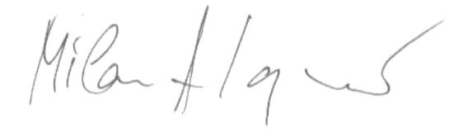
Milan Antonijević, Director of YUCOM

Belgrade, December 12th 2013

Conference:
Challenges in Human Rights Protection and in Supporting Socially Disadvantaged
Media Centre Belgrade, Friday December 20th 2013, 12:00h
3 Terazije st, Belgrade, Conference hall on 1st floor

12:00-12:15 Address speech
Milan Antonijević, Director of YUCOM
Sumeja Tulić, Programme Officer CRD
His Excellency Heinz Wilhelm, German Ambassador to Serbia
12:15-13:00 Human Rights before courts
Moderator: Milan Antonijević, YUCOM
Natalija Šolić, Atty YUCOM
Kristina Todorović, Atty YUCOM
Katarina Golubović, Atty YUCOM

13:00 – 13:15 Coffe break
13:15– 14:00 Challenges of human rights defenders
Moderator: Maša Mileusnić, journalist
Biljana Srbljanović, human rights defender
Aida Ćorović, human rights defender
Danko Runić, Heartefact Fund
Miloš Urošević, Women in Black

14:00 – 14:45 Status of the socially disadvantiged and the right to adequate housing
Moderator: Goran Jevtić, actor
Jelica Mišković, Roma Coordinator, Odžaci muinicipality
Veljko Žigić , director of Association of Refugees from Croatia
Nikola Grujić, lawyer YUCOM

14:45 – 15:00 Discussion
15:00 Cocktail

