**DRAFT – CROSS COUNTRY COMPARISON**

CONDUCTED BY LAWYERS' COMMITTEE FOR HUMAN RIGHTS - YUCOM

YUCOM had conducted limited survey of FLA systems in Montenegro, Bosnia (Brčko), Lithuania, Croatia and Slovenia. Through comparison with other countries and through usage of good practice we believe that Serbian system of FLA could be more effective, more carefully designed and more opened to citizens, once it starts operating. We wanted to avoid errors that some countries faced, such as too complicated and not cost-effective system of approving the right to FLA, as well as system missing the needs of citizens of specific country.

We have elaborated legal framework and implementation of FLA laws, with special focus to costs that each of the systems gives in order to have functional FLA.

Each of the countries chosen for this survey gives a lot of data and lot of thoughts could be raised.

As YUCOM used both interviews, semi structured questionnaires and data collection, using in large numbers Free Access to Information in 5 countries, we have the right to say that different angles of FLA in designated countries we covered. Through direct contact with representatives of the relevant ministries, bar chambers, offices for free legal aid in these countries and other stakeholders we got the chance to go deeper in the system of free legal aid.

At the end in this document we offer a picture of paths that Serbia could choose in order to provide its citizens with effective and accessible free legal aid.

YUCOM team

January 2014.

***CONTENTS***

***INTRODUCTION***

**MONTENEGRO**

**I GENERAL INFORMATION ON FREE LEGAL AID LEGAL FRAMEWORK**

1. **Beneficiaries**
2. **The procedure for the approving of free legal aid**
3. **Types of legal aid**
4. **Non-eligible procedure/matters for granting FLA**
5. **FLA providers**
6. **Funding**
7. **Register**
8. **Supervision**

**II IMPLEMENTATION OF FREE LEGAL AID**

**CROATIA**

**I GENERAL INFORMATION ON FREE LEGAL AID LEGAL FRAMEWORK**

1. **Beneficiaries**
2. **Types of free legal aid**
3. **Eligible procedure/matters for granting FLA**
4. **FLA providers**
5. **Funding**
6. **Register**
7. **Supervision**

**II IMPLEMENTATION OF FREE LEGAL AID**

**SLOVENIA**

**I GENERAL INFORMATION ON FREE LEGAL AID LEGAL FRAMEWORK**

1. **Beneficiaries**
2. **The procedure for the approving of free legal aid**
3. **Types of FLA**
4. **FLA providers**
5. **Funding**
6. **Supervision**

**II IMPLEMENTATION OF FREE LEGAL AID**

**BRCKO DISTRICT**

**I GENERAL INFORMATION ON FREE LEGAL AID LEGAL FRAMEWORK**

1. **Beneficiaries**
2. **The procedure for the approving of free legal aid**
3. **Types of FLA**
4. **Eligible procedure/matters for granting FLA**
5. **FLA providers**
6. **Funding**
7. **Supervision**

**II IMPLEMENTATION OF FREE LEGAL AID**

**COMPARATIVE OVERVIEW**

**CONCLUSIONS/SUMMARY**

**Basic reccomendations**

**MONTENEGRO**

**I GENERAL INFORMATION ON FREE LEGAL AID LEGAL FRAMEWORK**

On April 15th 2011 Montenegro adopted the Law on Free Legal Aid. Act is being applied **since January 1st 2012**. As stated by the government, the law was passed with the aim to provide free legal assistance, in order to achieve right to fair trial and equal access to courts, to people who due to financial condition are unable to exercise their right to judicial protection without damaging the necessary support of themselves and their families.

The Law regulates the issues of conditions and the right to free legal assistance, the principle related to legal assistance, the process of approval of free legal aid; way of achieving free legal assistance in disputes with a foreign element, record keeping, financing activities and fees for provided services, as well as control over the provision of free legal assistance and supervision of the implementation of the law.

The *European Commission* has emphasized the issue in its progress report on Montenegro for 2012 and expressed the concern that “Montenegro remains one of the countries with the highest number of basic courts, judges, prosecutors and administrative staff per capita in Europe. Due to this high administrative cost, **there are not enough budget resources to implement the new Law on Free Legal Aid** or to remedy shortfalls in infrastructure and equipment, which continue to hinder judicial efficiency. The quality of judicial statistics needs to be improved and a system to monitor the length of trials introduced.“ ... „With regard to access to justice, some progress has been made. The Law on Free Legal Aid came into effect in January and **relevant services are now available in all the basic courts in Montenegro**. Nevertheless, certain categories of people are not covered. Administrative capacity needs further development. The length of court proceedings remains an issue of concern.“ ...

„As regards access to justice, following the entry into force of the Law on Free Legal Aid in January 2012, three implementing acts were adopted and free legal aid offices were opened in all basic courts. The implementation of the law is hampered by the offices’ insufficient budget. The 2012 budget for the judiciary and the prosecution is € 24.9 million, which represents approximately 0.75 % of the GDP. As the salaries of magistrates and administrative staff continue to account for most of this total, there are not enough resources to remedy deficiencies in infrastructure and equipment, which continue to hinder efficiency. Initial steps have been taken to rationalize the court network, but Montenegro continues to be one of the countries with the highest number of basic courts, judges, prosecutors and administrative staff per capita in Europe.“[1]

In its progress report on Montenegro for 2013, European Commission repeated: „As regards access to justice, the implementation of the law on free legal aid through the free legal aid offices established in all basic courts continues to be hampered by the offices’ insufficient budget and the lack of public awareness. Free legal aid services are inaccessible to some ethnic groups due to linguistic barriers. The timeframe established by law for deciding whether an application meets the eligibility criteria is considered to be **extremely short**.“[2]

*United Nations High Commissioner for Refugees* has emphasizedthat**free legal aid provided based on this law is limited to court procedures.** „Currently, marginalized groups are left in a precarious situation without access to legal procedures and protection of their basic rights. UNHCR has been funding the provision of free legal aid for persons of its concern in Montenegro for a number of years. However, the need for free legal assistance remains high, especially for SGBV cases among displaced persons. The Law covers only judicial procedures and not administrative procedures, which are mainly of benefit for UNHCR’s persons of concern.“[3]

**1.Beneficiaries**

The law has the standpoint that holders of the right to free legal assistance, as an individual human right, can only be **natural persons (not legal entities).[4]**

Population of Montenegro is **625 266 citizens**.

The law stipulates that the right to free legal assistance, in accordance with the law, exercise Montenegrin citizens, stateless persons and other persons lawfully residing in the country, asylum seekers and foreigners who have permanent residence or who have been granted temporary stay in the country, which is in agreement with the standards of the ECHR.

When it comes to the persons who are entitled to free legal aid, law identifies as priority categories: **indigent persons** (not necessarily only those who are beneficiaries of social protection), children without parental care, persons with disabilities and victims of crimes of domestic violence/family community and human trafficking.

The law in Art. 6 regulates that a person who has exercised the right to free legal assistance by other law, may not under this Act be entitled to the same form of legal aid in the same matter.

There are **45600[5] beneficiaries of family cash benefits.**

1. **The procedure for the approving of free legal aid**

Legal aid offices[6] or sections are formed within every basic court in Montenegro (15) and they are in charge of technical and administrative tasks in the process of granting legal aid.

Office is obliged to provide information and advices to all interested parties regarding the possibilities and terms for exercising the right to free legal aid.

Applications for free legal aid approval services shall be submitted to the competent court, in the unique form which can be obtained at any basic court or office for legal aid. Data on applicants or their family members real property and tax obligations Office obtains within 15 days.

Based on that data, the president of the court or a judge who is in charge of examining applications (according to annual schedule) issues a decision for granting free legal aid. These decisions shall be kept on register and these records can periodically be claimed by the Ministry of Justice. It also presents register of the number of all beneficiaries of free legal aid system.

Against the decision of the President of the Court on the application for legal aid, which is final, administrative action may be led. So far, regarding this issue, Administrative Court was deciding within four months.

An applicant who has been granted free legal aid is given directive which, inter alia, includes: form of approved legal aid, name of the lawyer who is assigned, brief description of the legal matter for which the legal aid is being granted. During the period from approval of free legal aid to the day of the final cost calculation, a person to whom legal aid is granted shall be obliged to inform the Office about the changes in his/hers financial status. If the user of the right to free legal aid fully or partially succeeds in the proceeding, and so acquired the property (or any kind of income) he will be obligated to return/cover cost of the approved legal aid to the Budget.

The Service employs at least one person meeting the requirements for performing the tasks of advisors with courts.The president of the court may assign advisors with the court, judicial trainees and volunteers to work within the Service.

For example: in Bjelo Polje – 1 advisor with the court has meetings with clients on working days from 12 PM to 3 PM; in Herceg Novi – 1 advisor on Monday and Wednesday from 8.30 AM to 10.30 AM. In Herceg Novi, according to Annual work schedule, there is Section for free legal aid. The body for approving free legal aid is one of the judges of the Court.

In Berane, according to the Annual work schedule, there is Office. One advisor with court and Secretary of Court works with clients on Wednesday and Friday from 11 AM to 13 PM.

1. **Types of legal aid**

When it comes to the types of legal aid, the law defines the right to legal counsel, drafting documents and legal representation.

Legal representation considers representation before the state prosecution, courts and the Constitutional Court, but not for representation in administrative proceedings, commercial disputes, proceedings conducted by independent regulatory bodies and proceedings for damages in respect of defamation and contempt.

1. **Non-eligible procedure/matters for granting FLA**

Legal aid shall not be provided in:

1) Proceedings before commercial courts and in the procedure for registration of a commercial activity,

2) In criminal proceedings and the indemnification proceedings concerning defamation and libel,

3) Proceedings as per action to reduce the amount of child support in a case of the person obliged to pay support who failed to do so, unless in default of such obligation without any fault of his own.

1. **FLA providers**

Legal aid is **provided by lawyers (685)** according to order from the list of the Bar Association of Montenegro compiled as per territorial jurisdiction of basic courts.  
          Legal advising can be provided by the Legal Aid Office of the competent court. According to advisors, the Office still hasn’t been enough recognized as free legal aid provider.

* **Trainings in Montenegro**

Since the Law on FLA defines that providers of FLA are lawyers, trainings in Montenegro are organized for the decision makers in the process of granting FLA.

During the year 2012, which is the first year of implementation of Law on Free Legal Aid, three roundtables on the topic of the Free legal Aid were organized.[7] The aim of these round tables was resolution of practical dilemma regarding conditions under which free legal assistance can be provide; representation of the scope of approved providers; types of legal aid; subjects who can use free legal aid services; procedures which guarantee the right to free legal aid for the citizens, all in accordance with the Law. The first was intended for presidents of basic courts and counselors who work in free legal aid offices, with the goal of exchanging the experiences and solutions to the problems related to the implementation of the Law on Legal Aid (a total of 19 participants). The second round table was also dedicated to the representatives of the judiciary, as well as representatives of state bodies involved in the implementation of the Law (20 participants, including 15 representatives of the judiciary, five representatives of state authority (Real Property Management, Central Depository Agency, representatives of the Centers for Social Work of Podgorica, Niksic and Bar)). And the third one gathered representatives of the judicial and non-governmental organizations interested in the implementation of this Law (attended by 22 participants, including 15 representatives of the judiciary and 7 NGO representatives).

1. **Funding**

Article 9 stipulates that funding for legal aid is provided from the state budget of Montenegro.

Lawyers charge 50% of the regular tariff of legal practitioner. In the end of proceedings they submit costs to Legal Aid Office. Based on the bill of costs, president of the court issues a decision regarding the costs, which is a final document. Decision is sent to Court Council in charge of paying the lawyers. The Law regulates cost obligations of the client towards the State.

1. **Register**

Legal Aid Offices keep on register of new requests and approved applications for free legal aid, which is available for the Ministry of Justice. Records are concentrated more on the elements of requests for legal aid (data on the applicant and his family members, the number of cases and forms of aid provided, number and date of decision, the amount of funds disbursed), than on the type and content of the proceedings to which legal aid have been granted, which may affect the evaluation of results. Furthermore, if one takes into account that the Act does not limit other agencies and organizations in providing legal aid (Article 5), then it would be necessary to prescribe the obligation of all legal aid providers to keep track of free legal aid and to provide this information promptly to the body that is responsible for the coordination and control of the legal aid system .

1. **Supervision**

The issue of control over the quality of free legal encompasses elements and mechanisms of establishing the quality of FLA, but also the elements and procedures of quality control procedures to be carried out subsequently. Quality is being ensured and controlled in relation to the contents of free legal aid services and procedures under which they are provided, which takes into account the relationship between the fee for the cost of the service provided and the quality of the same. Articles 63 - 65 stipulate that the administrative supervision of the implementation of the Act is carried out by the Ministry of Justice, while overseeing the quality of legal aid is delegated to the authority before which the proceedings in which legal aid is granted are conducted. In case that the authority that acts in the case for which legal aid is granted, assess the quality of legal aid as obviously unsatisfactory it has the right and obligation to inform the beneficiary and authority that make decisions on its approval.

This means that the judge has the obligation to inform the President of the competent basic court, as well as the beneficiary of free legal aid, about misbehaving and mal-performance of the lawyer.

Although this is a good solution because it allows direct control over the quality of provided legal aid, it is not well specified. More detailed data on what constitutes quality of legal aid is obviously missing, evaluates acting organ praeter legem.

In addition, beside the decision to change counsel and procedural sanctions that may be imposed by the authority acting in the procedure, there is no direct authorization of the competent authority to impose disciplinary measures or sanctions, but only to put a proposal to the Bar Association for removal from the list of lawyers. These provisions did not elaborate proceedings on complaints of users, which is one of the important mechanisms of quality control, regardless of the fact that the competent authority is obliged to look after the quality of legal assistance ex officio.

Article 63, in paragraph 3 provides that legal aid user has the right to submit a request to change lawyer, on which the competent authority shall decide within eight days. This paragraph can be interpreted as if the application by the user depends on previous assessment of involved body that legal aid is obviously unsatisfactory, even though the beneficiary should have the right and obligation to object to quality of legal assistance at any time, and to inform the acting authority.

**II IMPLEMENTATION OF FREE LEGAL AID**

In year 2012, which is the first year of the implementation of Law on Free Legal Aid, citizens filed 428 applications for approval of FLA. It was granted in 304 cases. Users of FLA were citizens of Montenegro in 332 cases, while in the remaining 34 cases users were foreign nationals who have permanent residence or temporary stay permit, as well as one stateless person. FLA was granted on the basis of family allowance or other rights of social protection in 168 cases, in four cases to persons with special needs, in a single case to victim of act of domestic violence and human trafficking, and in 141 case users were indigent individuals.

In 2012 following **forms of FLA were granted**: 1) legal advice - 11, 2) preparation of documents - 50, 3) legal advice and representation in proceedings before the State Prosecutor's Office - 2, 4) legal advice and representation in proceedings before the courts of first and second instance – 263.

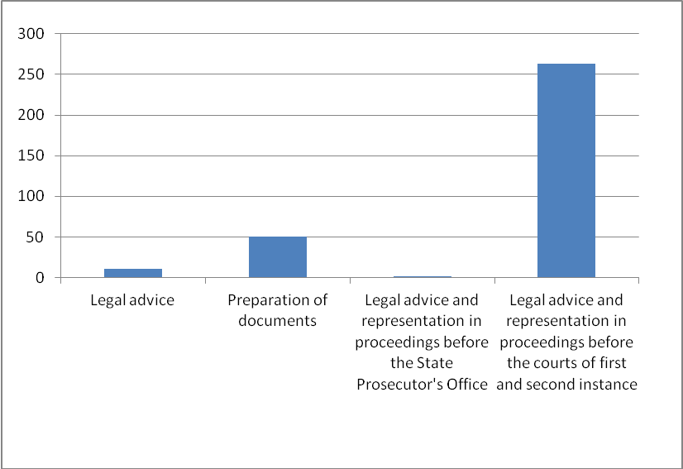

For the period 01.01.2012 - 31.12.2013, on behalf of free legal aid lawyer’s was approved an amount of 24,483.38 euro. Of this amount, 9,342.02 is paid to lawyer’s,while the remaining 15,141.36 euro isn’t yet paid. State is given on January 21st 2014. For 2014., the planned funds for this purpose are 380,000.00 euro.[8]

It is evident that the Budget of the Republic of Montenegro does not particularly provide funds for the implementation of the Law on Free Legal Aid. The part of the Budget – Judiciary (subpart-contractual services) is predicted for lawyers` expenditures.

However, taking into account that legal aid offices and services are usually placed in courtrooms[9], and that the lawyers can work with parties only for 4 hours per week (eg, Herceg Novi); the tasks of gathering documents for granting legal aid is performed by counselors; and that the decision on the approval of applications is issued by the President of the court or a judge designated by him, it is abvious that system of granting free legal aid does not require special tools, because the approval of free legal aid is a part of regular assignment of basic court stuff.

* **Planned improvement of the legal aid system**

According to the Strategy of reform of judiciary (2014-2018)[10] the so far implementation of the Law on Free Legal Aid showed the existence of some disadvantages that need to be eliminated in order to ensure efficient and effective access to justice. Past practice has shown many **violations of the deadline for acting on requests for free legal aid**. Also, **informing the general public on the existence of free legal aid and possibilities given by the Law on Legal Aid is not satisfactory**. Victims of torture and discrimination are not recognized as privileged beneficiaries of free legal aid. So far, adequate **mechanisms and indicators for monitoring the quality of provided legal aid are not provided.** The cooperation between the offices of free legal aid in basic courts and NGOs involved in the protection of vulnerable social categories also has flaws.

Strategic guidelines are identified as follows:

* Providing a higher level of information to the general public about the free legal aid system;
* Improving the legal framework through amendments to the Law on Legal Aid in terms property threshold specified by law in order to comply with changes to the welfare and protection of children and the conditions in securities market;
* Developing mechanisms and indicators for monitoring the quality of provided legal aid;
* Improving cooperation between the offices of free legal aid within basic courts and NGOs involved in the protection of vulnerable social groups in order to promote the institute of free legal aid among potential users in this group;
* Promoting free legal aid among students of legal sciences through the implementation of the curriculum of clinical legal education at the universities of Montenegro.

**CROATIA**

**I GENERAL INFORMATION ON FREE LEGAL AID LEGAL FRAMEWORK**

In Croatia, Free Legal Aid Act is adopted in 2008[11]. The implementation of FLA is regulated by several by-laws: 1)Ordinance establishing the application form for the approval of free legal aid, the order form and the record of the orders issued (OG [148/11](http://narodne-novine.nn.hr/clanci/sluzbeni/2011_12_148_2994.html)); 2) Ordinance establishing the project valuation criteria of associations authorized to provide primary legal aid and legal clinics and establishing the method of project reporting (OG [148/11](http://narodne-novine.nn.hr/clanci/sluzbeni/2011_12_148_2995.html)); 3) Ordinance establishing the keeping of the register of associations authorized to provide free legal aid (OG [93/08](http://narodne-novine.nn.hr/clanci/sluzbeni/2008_08_93_2949.html)); and 4) Regulation on the tariff for determining the value of the amount of compensation for providing primary and secondary legal aid for 2013 (OG[36/13](http://narodne-novine.nn.hr/clanci/sluzbeni/2013_03_36_658.html)).

The European Commission has emphasized the issue in its progress report on Croatia for 2011 and expressed the concern that **“**Implementation of legal aid system has improved, including by means of simplified application procedures and a narrowing of the gap between legal aid and normal lawyers' tariffs. The Constitutional court revoked some provisions of the Law on Legal Aid in April 2011. Provisions concerning the formulation of eligibility criteria, determination of beneficiaries for legal aid; apportioning of the budget for free legal aid and the refusal by attorneys to take on legal aid cases were subsequently amended in July 2011. However, further improvements to the system are needed, including in terms of facilitating access to legal aid as well as fostering the role of NGOs. Implementation of the new system of administrative justice needs to be speeded up[12].

In 2012, European Commission said that “the legal framework for free legal aid has to be improved to enable better access to legal aid and to foster the role of NGOs as legal aid providers.”[13]

1. **Beneficiaries**

According to the Act, the beneficiaries of free legal aid are Croatian citizens, foreigners with temporary residence, foreigners with permanent residence, asylees, foreigners under subsidiary protection and foreigners under temporary protection. The beneficiaries of legal aid are also the asylum seekers in procedures for which legal aid to asylum seekers is not envisaged by a special law.

Foreigners with temporary residence and foreigners with permanent residence may exercise the right to legal aid under the condition of reciprocity.

The beneficiaries of legal aid are foreign children who are in the Republic of Croatia without a parent or legal guardian.

The beneficiaries of legal aid are foreigners who illegally reside and foreigners on a short-term stay who are in the procedure of adopting a decision on deportation and in the procedure of adopting a decision on leaving the Republic of Croatia[14].

* **Criteria for the approval of legal aid**

Primary legal aid can be exercised under the following criteria:

a) the applicant does not have sufficient knowledge and ability to exercise the right;

b) legal aid is not provided to the applicant according to special regulations;

c) the material circumstances of the applicant are such that the hiring of professional legal assistance would jeopardize the maintenance of the applicant and the members of his/her household, in accordance with the conditions prescribed by Article 8 of this Act.

Secondary legal aid can be exercised under the following criteria:

a) if it relates to a more complex procedure;

b) the applicant is not able to represent himself/herself;

c) the request submitted by the applicant is not obviously unfounded, or unrealizable;

d) the material circumstances of the applicant are such that hiring a lawyer  would jeopardize the maintenance of the applicant and the members of his/her household, in accordance with the conditions prescribed by Article 8 of this Act.

e) if it does not relate to wanton litigation[15].

Legal aid shall be approved when the financial situation of the applicant and members of his/her household meets the following criteria:

a) the total income and revenue of the applicant and adult members of his/her household each month do not exceed, per member of the household, the amount of the lowest base for calculation and payment of contributions for obligatory insurance on the day the application is submitted, pursuant to the Act on Obligatory Insurance Contributions;

b) the applicant or adult members of his/her household do not possess assets, in monetary or non-monetary form, except for real estates, whose total value exceed the amount of twenty of the lowest monetary bases for calculation and payment of contributions for obligatory insurance on the day the application is submitted, pursuant to the Act on Obligatory Insurance Contributions;

c) the applicant or adult members of his/her household do not own, except for the flat or house they live in, a flat or house or another real estate;

d) the applicant or adult member of his/her household do not own a vehicle whose value exceed eighteen of the lowest monthly bases for calculation and payment of contributions for obligatory insurance on the day of submitting the application, pursuant to the Act on Obligatory Insurance Contributions.

Exceptionally, legal aid will be granted to the applicants who do not fulfill the previously mentioned criteria if their financial status is such that, with regard to the actual or predictable expenses of the procedure, the payment of the costs of the procedures would endanger the maintenance of the applicant and members of his/her household. Legal aid shall also be granted to children whose parents or other persons are obliged to support them according to the provisions of the law, in proceedings conducted before competent bodies for exercising the rights of children to maintenance regardless of the financial status of the family.

Legal aid shall be granted without determining the financial status if:

a) a person has been granted the right to maintenance in accordance with special regulations governing the exercise of rights from the social welfare system or

b) the right to maintenance pursuant to the Act on the Rights of Croatian Homeland War Veterans and Members of their Families and the Act on Protection of Military and Civilian War Invalids.

The approval of legal aid relates to the complete or partial payment of the costs of legal aid according to the financial situation of the applicant. In fact, it has been foreseen the possibility for the beneficiary of legal aid to participate to the costs of the proceeding, in a determined amount, depending on his/her financial possibility.

1. **Types of free legal aid**

In Croatia, types of FLA are:

a) Primary legal aid

b) Secondary legal aid

c) Exemption form payment of court fees

d) Exemption from payment of court procedure costs

Primary legal aid includes:

* Legal advice
* drafting of applications before public authorities
* representation in procedures before public authorities
* legal aid provided in peaceful out-of-court settlement of disputes

Secondary legal aid includes:

* legal advice
* drafting of applications in court procedures
* representation in court procedures
* legal aid provided in peaceful settlement of disputes

The approval of secondary legal aid includes the exemption from payment of court fees and costs of the proceeding.

The approval of exemption from payment of costs of the proceeding includes the exemption from payment of court fees.

1. **Eligible procedure/matters for granting FLA**

Primary legal aid may be approved in the following procedures:

a) relating to the status rights of citizens;

b) relating to the determination of rights and obligations from the pension and/or health insurance;

c) relating to the determination of rights and obligation form the social care system;

d) exceptionally, in all other administrative procedures when this need arises from specific life circumstances of the applicant and members of his/her household, in accordance with the basic objective and purpose of this Act;

e) protection of workers’ rights before the employer.

Secondary legal aid may be approved in the following procedures:

a) relating to real rights, except for land registry procedures;

b) labor relations;

c) family relations;

d) enforcement procedures and security procedures when it relates to involuntary collection or security of a claim arising from the procedure for which legal aid may be approved, according to the provisions of this Act;

e) peaceful settlement of disputes;

f) exceptionally, in all other administrative procedures when this need arises from specific life circumstances of the applicant and members of his/her household, in accordance with the basic objective and purpose of this Act;

Exceptionally, the court may approve legal aid, in judicial procedures, for reasons of fairness upon the request of the party who does not fulfill the criteria prescribed by law.

1. **FLA providers**

The Free Legal Aid Act envisages as legal aid providers: lawyers (269), authorized associations (35), trade unions, legal clinics (2)[16] and state administration offices (29 state administration offices, 64 municipal courts, 91 social welfare centers) in the counties where the forms of legal aid that each entity may provide have been defined.

**In the Register organizations that provide legal aid there are 35 registered authorized associations. [17]**

**5. Funding**

Funding for the organization of the system and providing legal assistance on the basis of the decision on the approval of legal aid is provided by the state budget. Minister of Justice makes the decision on allocation of funds to finance projects of registred providers of primary legal aid.

Every year, Ministry of Justice announces a public tender for the allocation of funds to finance projects of CSOs registred for providing free legal aid and legal clinics of law faculties.

Every year, Ministry of Justice announces a public tender for the allocation of funds to finance projects of CSOs registred for providing free legal aid and legal clinics of law faculties. In 2012, 12 projects of registred CSOs and legal clinics were financed. In this way, to the Legal Clinic in Zagreb and registred CSOs for providing legal assistance projects from the state budget in the 2012, a total amount of 200,397.05 kunas (26,493.53 euros) was allocated.

According to data from the State Treasury in 2012 for the Legal aid total amount of 2,278,000.00 kunas (301,163.41 euros) was planned. The amendments to the State Budget for year 2012 planned assets are reduced to the sum of 1,261,500.00 kunas (166,776.84 euros).

In the reporting period for legal aid total of 1,258,134.89 kunas (166,331.95 euros) has been spent, while the reserved funds (payment is expected in the next period ) amounted to 5,238,172.78 kunas (692,513.59 euros)[18].

1. **Register**

According to the Article 11 of Ordinance establishing the application form for the approval of free legal aid, the order form and the record of the orders issued (OG [148/11](http://narodne-novine.nn.hr/clanci/sluzbeni/2011_12_148_2994.html)), district office of state administration and office of City of Zagreb keep records on applications and granted FLA and expenditures. Records are kept in electronic form.

**7. Supervision**

* **Administrative Supervision**

Administrative supervision of the implementation of FLA Act is carried out by the ministry responsible for justice affairs. The Ministry in particular supervise the work of the competent office in giving approval for legal aid.

* **Professional supervision**

Supervision of the conscientious and professional provision of legal aid is performed *ex officio* by the body before which the proceedings are being conducted for which the party is exercising the right to legal aid.

Furthermore, supervision of the work of associations is also performed directly by the ministry responsible for justice affairs, which carry out an inspection at least once in two years of the provision of legal aid by the association.

When the body before which the proceedings are being conducted establishes that legal aid has been provided negligently or unprofessionally, it shall make a note of this in the file and point this fact out to the provider of legal aid, the beneficiary of legal aid, the body which issued the order and the ministry responsible for justice affairs.

A beneficiary of legal aid, who has been warned of the negligent or unprofessional provision of legal aid, has the right to withdraw the order and chose another provider of legal aid. The provider of legal aid has the right to calculate the costs up until the moment the order was withdrawn, except for the legal actions immediately preceding the withdrawal of the order.

The beneficiary of legal aid is obliged to inform the office about the change of provider of legal aid, or, if he/she is to relinquish the right to legal aid, to return the order according to the provisions of this Act.

* **Supervision of lawyers**

If the legal aid was provided by an attorney, the ministry responsible for justice affairs shall inform the Croatian Bar Association of the unprofessional or negligent provision of legal aid.

* **Supervision of authorized association**

If the legal aid was provided by an authorized association, the ministry responsible for justice affairs shall re-examine the authority for providing legal aid and enter a note of this in the register. In cases of negligent or unprofessional provision of legal aid by an association, a decision shall be rendered to prohibit it from providing legal aid and delete it from the register of associations providing legal aid.

* **Supervision of Law clinic**

If the legal aid was provided by a law clinic, the ministry responsible for justice affairs shall inform the institution of higher education offering university studies in law of the negligent and unprofessional provision of legal aid.

**II IMPLEMENTATION OF FREE LEGAL AID**

According to the *Ministry of Justice Report on Exercise of Right to Free Legal Aid and Utilization of Funds in 2012*[19], citizens filed **7068** applications for approval of FLA. It was granted in **5877** cases.

The vast majority of beneficiaries were Croatian citizens - 5775 and 100 were foreigner nationals.

In 2012 following **forms of FLA were granted**: 4936 as secondary FLA (83,94%) while 448 as primary FLA (7,62%).

Whithin the 448 granted cases of primary free legal aid the structure is the following:

* 404 in drafting of applications before public authorities (90,18%).
* 44 in representation in procedures before public authorities (9,82%).

Whithin the 4936 granted cases of secondary free legal aid the structure is the following:

* 314 in drafting of applications in court procedures (6,36%).
* 4622 in representation in court procedures (93,64%).



Within the 5877 granted cases of legal aid, the structure is the following:

* **Court procedure**
* 3158 in family matters
* 793 in executive procedures
* 514 in property matters
* 201 in labour case
* 477 in other court cases
* 70 in administrative disputes
* 8 in procedures on extraordinary remedies
* 13 in Procedures before Constitutional Court
* **Administrative procedure**
* 231 in pension and health insurance matters
* 189 in social welfare matters
* 37 in status matters
* 17 in residents and working permits matters
* 140 in other administrative matters
* 9 in procedures before employers
* 19 in **alternative dispute resolution procedure**

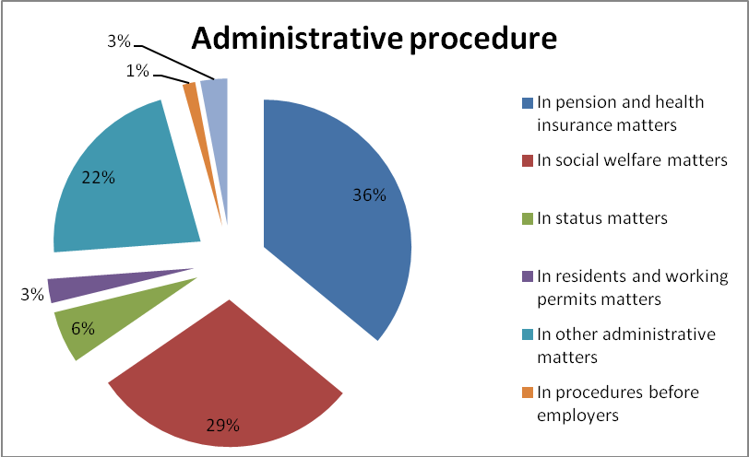

Free legal aid was provided by lawyers in 78,2%, while 21,9 % by registered CSOs.

* **Budgetary data for 2012**

In 2012, 12 projects of registred CSOs and legal clinics were financed. In this way, **to the Legal Clinic in Zagreb and registred CSOs** for providing legal assistance projects from the state budget in the 2012 a total amount of 200,397.05 kunas (**26,493.53 euros**) was allocated.

According to data from the State Treasury in 2012 for the Legal aid total amount of 2,278,000.00 kunas (301,163.41 euros) was planned. The amendments to the State Budget for year 2012 planned assets are reduced to the sum of 1,261,500.00 kunas (166,776.84 euros).

In the reporting period for legal aid total of 1,258,134.89 kunas (**166,331.95 euros**) has been **spent**, while the **reserved funds[20]** (payment is expected in the next period ) amounted to 5,238,172.78 kunas (**692,513.59 euros**)[21].

**SLOVENIA**

**I GENERAL INFORMATION ON FREE LEGAL AID LEGAL FRAMEWORK**

Actual Law on Free Legal aid in Slovenia was brought in 2001, while the last amendments entered into force in 2008 [22]. The Ombudsman considered that access to legal protection is very difficult for individuals who are weaker in social or economic terms. It is especially alarming that legal aid is very difficult to receive in lawsuits concerning child support, where the plaintiff -parent has to cover the costs of the court procedure[23].

The constitution and law provide for the right to a public fair trial, and an independent judiciary generally enforced this right. Defendants enjoy the right to a presumption of innocence; a trial by jury; to consult with an attorney; to confront prosecution witnesses and present their own witnesses and evidence; access government-held evidence; and appeal. While indigent defendants have the right to an attorney provided at public expense, the government had not established a formal system to provide legal counsel to the indigent. However, free counsel was available to indigents from the nongovernmental organization (NGO) PIC (Legal Information Center) and the government-sponsored Free Legal Aid. The judicial system was overburdened and lacked administrative support, resulting in frequent delays in the judicial process. In many instances criminal trials took from two to five years. [24]

**1. Beneficiaries**

The law prescribes that legal aid shall mean the right of the eligible person to the entire or partial provision of funds necessary to cover the costs of legal assistance and the right to exemption of payment of the costs of the judicial proceeding (Free Legal Aid Act, Article 1).

1. **The procedure for the exercising of free legal aid**

Free legal Aid Act[25] stipulates that competent free legal aid authority will apply general administrative procedure, unless otherwise provided by the Act.

Application for free legal aid should include prescribed application form. It should be filed to the competent free legal aid authority operating at the court based in the region where the applicant has his or her permanent or temporary residence or where his or her head office is based. The competent legal aid authority collects data on the applicant or eligible person or opposing party, and other data when and if this is necessary in order to:

* approve free legal aid;
* verify the data specified in the application;
* ensure the repayment of funds paid as the result of unjustifiably received free legal aid;
* collect the amounts owed pursuant to this Act in the enforcement procedure.

The applicant may, for well-founded reasons, request priority consideration of the application by the competent free legal aid authority.

The president of the local court must ensure that applications received are sent immediately to the competent court. Competent free legal aid authority decides on applications for free legal aid upon by issuing a decision and, for proceeding-related issues, by issuing an order. When deciding on applications for free legal aid, the competent free legal aid authority takes into account the principle of expeditiousness and effectiveness of the proceedings. Decision includes determined or specified the explicit form and scope of the free legal aid granted, and set forth in more detail the matter for which free legal aid has been granted (e.g. the type, extent and date of completed acts of free legal aid and the person or authority that provided the free legal aid). The decision is also served on the Attorney General and the competent court before which the proceedings for which the free legal aid has been granted.

Generally, there is no appeal against the decision of the competent free legal aid authority; still, an administrative dispute is possible. An action in an administrative dispute may also be filed by the State Attorney General. Pursuant to The Free legal Aid Act, administrative dispute matters shall be deemed to be urgent.

1. **Types of FLA**

Further on the law defines that legal aid may be approved for legal advice, legal representation and other legal services laid down in this Act, for all forms of judicial protection before all courts of general jurisdiction and specialised courts based in the Republic of Slovenia, before the Constitutional Court of the Republic of Slovenia, and before all authorities, institutions or persons in the Republic of Slovenia authorised for out-of-court settlement (hereinafter referred to as: judicial proceedings), as well as in the form of exemption from payment of the costs of the judicial proceeding (Free Legal Aid Act, Article 7).

On the other hand the approved legal aid shall not cover the costs of the proceeding and actual expenditure of and remuneration for the person authorised by the opposing party (Free Legal Aid Act, Article 9).

The law specifically lists the costs that can be covered by the approved legal aid (Free Legal Aid Act, Article 26):

* for legal advice surpassing initial legal advice;
* for the formulation, verification and certification of documents on legal relations, facts and statements;
* for legal advice and representation in cases of out-of-court settlement;
* for legal advice and representation before courts in the first and second instances;
* for legal advice and representation involving extraordinary appeals;
* for legal advice and representation involving constitutional action;
* for legal advice and representation before international courts;
* for legal advice and representation involving the filing of a petition for the assessment of constitutionality;
* in the form of exemption from payment of the costs of the judicial proceeding.

Legal aid may also be granted in the form of an exemption from payment of the costs of proceedings before courts, particularly in the form of an exemption from payment of:

1. Court fees;

2. Costs of experts, witnesses, interpreters, servicing orders and translations, costs of external operations of the court or other authority in the Republic of Slovenia, and other justified costs;

3. Security deposits for the costs, or of the costs, of the implementation of the proceeding (advance payments);

4. Costs of public documents and receipts required for the proceeding before a court;

5. Other costs of the proceeding.

1. **Eligible procedure/matters for granting FLA**

Matters that can qualify for FLA granting are not defined explicitly, since the Law lay down matters that are to be seen as excluded from possible FLA granting consideration.

According to Article 8 of Free legal aid Act FLA shall not be granted in the following matters:

* + criminal offences involving insulting behavior, libel, defamation or slander, unless the injured party proves the probability that he or she has suffered legally recognised damage due to these offences;
  + disputes involving a reduction in maintenance when the person obliged to pay maintenance has failed to settle the due liabilities arising from maintenance, unless he or she has failed to settle these liabilities for reasons beyond his or her control;
  + in damage disputes involving compensation for non-property and property damage caused by defamation or libel, unless the injured party provides credible evidence that this has affected his or her material, financial or social position.

1. **FLA providers**

In Slovenia legal aid is provided by attorneys who pursuant to the act governing attorneyship (the Lawyer's Act) are entered in the Directory of Attorneys, by law firms founded on the basis of the act regulating attorneyship, and by notaries in matters dealt with pursuant to the act regulating notaries.

The request for free legal aid is decided by services (offices) for free legal aid at all district courts of the Republic of Slovenia (district courts are one of the two types of courts of first instance, exercising "major" jurisdiction).[26]

1. **Funding**

Funds for implementation of Free Legal Aid Act are provided from the budget of the Republic of Slovenia. However, if a person eligible for free legal aid was fully or partially successful in the proceedings and if he or she, on the basis of a court’s final decision or on the basis of an out-of-court or court settlement, acquires property or revenues, he or she is obliged to reimburse the Republic of Slovenia for the difference between the costs effectively paid as free legal aid and the amount repaid by the opposing party and arising from the costs of the proceedings, or the amount the Republic of Slovenia has collected from the opposing party pursuant. However, he/she may in no case be requested to repay a higher amount than he in fact obtained during the proceedings.[27]

In reporting period total of **6 562 466.95** euros was paid to FLA before district, administrative and labour and social courts in Slovenia.[28]

|  |  |
| --- | --- |
| Funds paid to FLA in cases before district courts | 6 228 606.93 |
| Funds paid to FLA in cases before administrative court | 570.17 |
| Funds paid to FLA in cases before labour and social courts | 333 289.85 |

1. **Supervision**

Para. 4 Art. 29 prescribes that minister responsible for justice sets regulations on supervision over the provision of legal aid in special bylaw.

According to Para.9 Art. 30 quality control of work of attorneys providing FLA is conducted by the competent free legal aid authority, which may decide to dismiss an appointed attorney who does not perform his/her services well, either at the request of the applicant or with his/her consent. The authority shall appoint another attorney in place of the one who was dismissed. The Bar Association or the Chamber of Notaries of Slovenia shall be notified of the dismissal.

**II IMPLEMENTATION OF FREE LEGAL AID**

According to Judicial Statistics of Ministry of Justice of Republic of Slovenia (Sodna Statistika)[29] during the reporting period (01.01. – 31.12.2012. 2012) FLA was granted to **8380** cases before three types of courts in Slovenia: district, administrative and labour and social courts. Cases to which FLA was granted:

* + civil 6039
  + labor 846
  + criminal 1032
  + other matters 357
  + minor offences 57
  + social 41
  + administrative 8

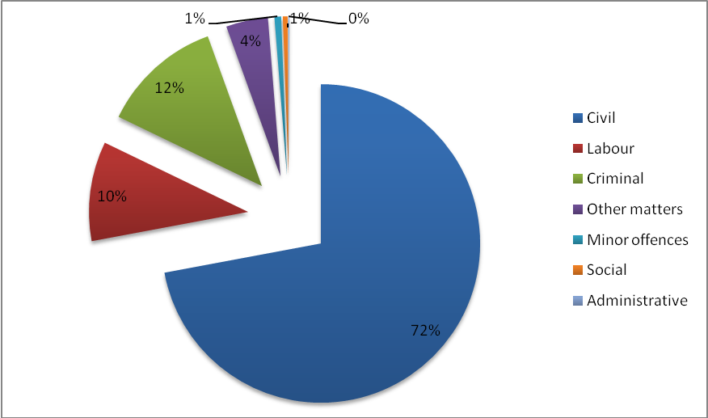

Before 11 district courts FLA was granted to 7302 cases:

* + civil 6038
  + labor 11
  + criminal 1032
  + other matters 157
  + minor offences 57
  + social 1
  + administrative 6

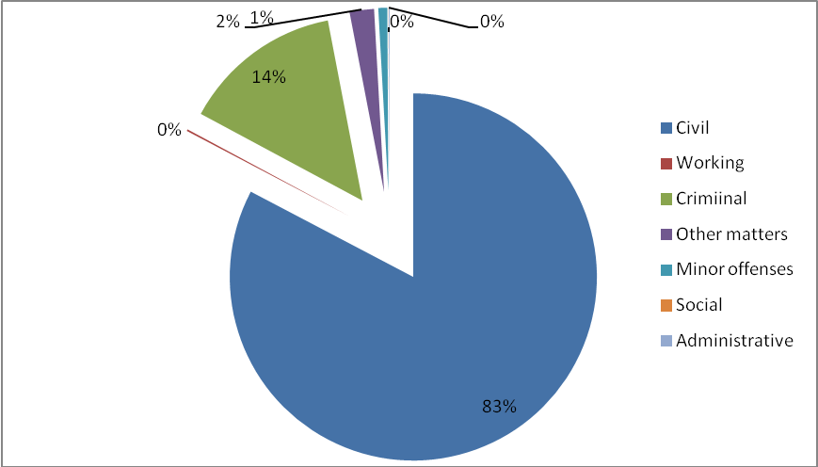

Before 1 administrative court FLA was granted to 2 cases:

* + civil 0
  + labor 0
  + criminal 0
  + other matters 0
  + minor offences 0
  + social 0
  + administrative 2

Before 4 labor and social courts FLA was granted in 1076 cases:

* + civil 1
  + labor 835
  + other matters 200
  + minor offences 0
  + social 40
  + administrative 0

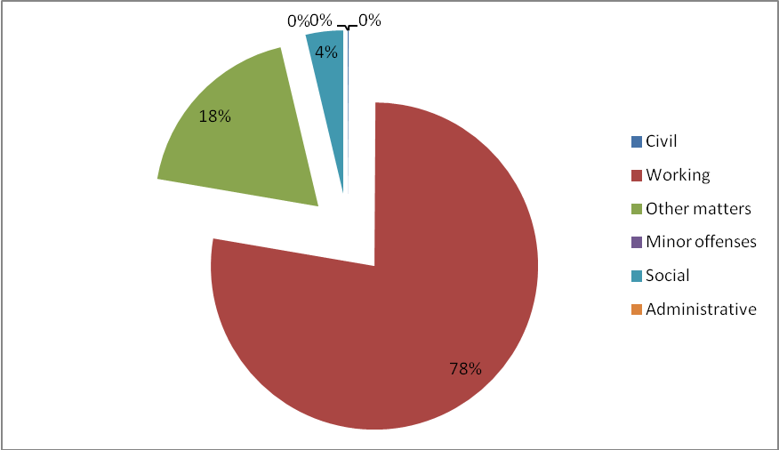

|  |  |
| --- | --- |
| **Type of procedural action in cases to which FLA was granted in reporting period**  **before all courts** | |
| Exemption from costs | 4073 |
| Legal advice and representation before international courts | 2 |
| Legal advice and representation before courts of first and second degree | 2074 |
| Legal advice and representation before courts of first degree | 3301 |
| Legal advice and representation before the courts in second degree | 175 |
| Legal advice and representation in lodging the initiative for assessing the constitutionality | 2 |
| Legal advice and representation in connection with extraordinary legal remedies | 42 |
| Legal advice and representation in connection with the constitutional complaint | 11 |
| Legal advice and representation for the conclusion of of-court settlement | 29 |
| Legal advice that goes beyond first legal advice | 207 |
| First legal advice | 218 |
| Composition, verification and validation of documents | 244 |

Total of **16126** cases were solved before district, administrative and labor and social courts in Slovenia in reporting period. Out of this number FLA was granted in **8380** cases.

|  |  |
| --- | --- |
| Unsolved cases at the beginning of period | 2194 |
| Recieved cases | 16311 |
| Solved cases | 16126 |
| Unsolved cases at the end of period | 2379 |

According to Para. 2 Art. 3 of Free legal aid Act it shall be granted as regular, extraordinary, exceptional, special or emergency free legal aid. The table below shows overview of these types of FLA granted in 2012:

|  |  |
| --- | --- |
| Exceptional | 18 |
| Extraordinary | 1976 |
| Emergency | 592 |
| Special | 18 |
| Regular | 5324 |

**LITHUANIA**

**I GENERAL INFORMATION ON FREE LEGAL AID LEGAL FRAMEWORK**

Lithuania has reformed Legal Aid System by adopting the Law of the Republic of Lithuania amending the Law on State-guaranteed legal aid (No X-78 of January 2005)[30].

The purpose of this law is to establish the provision of State-guaranteed legal aid to natural persons to enable them to adequately assert their violated or disputed rights and the interests protected under law.

1. **Beneficiaries**

Lithuanian law guarantees to **every person under the Lithuanian jurisdiction the right to receive free legal advice** or the so called “**primary legal aid**”. Population of Lithuania is 3 043 429 citizens. In 2012, persons who got PLA makes 1,48 % of Lithuanian population.

Lithuanian law guarantees free legal representation or “secondary legal aid” to persons with low income level. In 2012, persons who got SLA makes 1,66 % of Lithuanian population.

The following **persons shall be eligible for secondary legal aid** regardless of the property and income levels established by the Government of the Republic of Lithuania for the provision of legal aid under the Law on State-guaranteed legal aid:

1) the persons eligible for legal aid in criminal proceedings according to Article 51 of the Republic of Lithuania Code of Criminal Procedure (mandatory defense) and in other cases specified by laws when the physical presence of a defense lawyer is mandatory;

2) the aggrieved parties in the cases concerning compensation for the damage incurred through criminal actions, including the cases when the issue of compensation for damage is heard as part of a criminal matter;

3) the persons receiving a social allowance under the Republic of Lithuania Law on Cash Social Assistance for Low-Income Families (Single Residents);

4) the persons maintained in stationary care institutions;

5) the persons who have been established a severe disability or for whom incapacity for work has been recognized or who have reached the pensionable age and for whom the level of considerable special needs has been established, also guardians (custodians) of these persons, where State-guaranteed legal aid is required for the representation and defense of rights and interests of a ward (foster-child);

6) the persons who have presented a proof that they cannot dispose of their property and funds for objective reasons and that for these reasons, their property and annual income which they can freely dispose of do not exceed the property and income levels established by the Government of the Republic of Lithuania for the provision of legal aid under the Law on State guaranteed legal aid;

7) the persons suffering from serious mental disorders, when issues of their forced hospitalization and treatment are being considered according to the Republic of Lithuania Law on Mental Health Care, and their guardians (custodians), where State guaranteed legal aid is required for the representation of rights and interests of a foster-child (ward);

8) debtors in execution proceedings, when a recovery is levied against the last housing wherein they reside;

9) parents or other legal representatives of minor children, when the issue of their eviction is being considered;

10) minor children, when they independently apply to a court for the defense of their rights or interests protected under law in the cases specified by laws, with the exception of those who have entered into a marriage in accordance with the procedure laid down by laws or have been recognized by the court as legal capable (emancipated);

11) the persons who it is requested to recognize as legally incapable in the matters concerning recognition of a natural person as legal incapable;

12) persons in the matters concerning registration of birth;

13) other persons in the matters provided for in treaties of the Republic of Lithuania.

1. **The procedure for the approving of free legal aid**

A person wishing to receive secondary legal aid submits an application and the documents attesting to his/her eligibility for secondary legal aid to the Legal Aid Service (there are 5 Legal Aid Services whose jurisdiction correspond to the geographical areas of county courts).

* The eligibility for SLA of the persons whose property and annual income do not exceed the property and income levels established by the Government is attested to by a **resident’s property declaration** with a stamp of the **local tax administrator** confirming the submission of the declaration.
* The eligibility for SLA of the persons eligible for legal aid in criminal proceedings are attested to by the decisions of a pre-trial investigation officer, prosecutor or the court.
* The eligibility for SLA of the persons the aggrieved parties in the cases concerning compensation for the damage incurred through criminal actions is attested to by a decision of a pre-trial investigation officer, prosecutor or by a court ruling whereby a person is recognised the aggrieved party and/or by a court judgment.
* The eligibility for SLA of the persons eligible for a social allowance is attested to by a certificate issued by the **municipality** of the place of residence as declared by a person.
* The eligibility for SLA of the persons maintained by the State in stationary care institutions is attested to by a certificate issued by the **head of a stationary care institution**.
* The eligibility for SLA of the persons with disability is attested to by a document issued by the **Disability and Working Capacity Establishment Service under the Ministry of Social Security and Labor** and confirming the level of a person’s disability or incapacity for work.
* The eligibility for SLA of the poor persons is attested to by a property seizure act and/or other documents certifying the objective reasons for which a person cannot dispose of his property and funds as well as a copy of a resident’s property declaration submitted to the **local tax administrator**.
* The eligibility for SLA of the persons with serious mental disorders is attested by a certificate issued by a **health care institution**.
* The eligibility for SLA of the persons in the cases provided for in international treaties is attested by the documents specified in international treaties of the Republic of Lithuania.

The Service makes decision within 3 working days of the receipt of the applicant’s documents, in which it specifies the lawyer who provide SLA. Decisions of the service may be appealed against in accordance with the procedure laid down in the Republic of Lithuania Law on Administrative Proceedings.

When selecting a lawyer, the service shall take into account an applicant’s proposal regarding the specific lawyer, the place of residence of the applicant, the place of employment of the lawyer, the workload of the lawyer and other circumstances significant for the provision of secondary legal aid.

1. **Types of FLA**

Primary FLA includes:

* Legal information
* Legal advices
* Drafts of documents which should be submitted to state and government institutions (except process documents)
* Advices on alternative dispute resolution
* Peaceful settlement of disputes
* Preparation of a settlement agreement
* Filling requests for secondary FLA

Primary FLA is provided on: civil, administrative and criminal cases.

Primary legal aid is provided to everyone, regardless of income and assets.

Primary legal aid is provided to person immediately. If it is not possible, person will be notified of the time of an appointment, which must take place not later than 5 days from the day of application.

The duration of legal advice should not be longer than one hour. Its duration may be extended by a decision of the executive institution of a municipality or a person authorized by it.

A person may apply for primary legal aid on the same issue only once.

Secondary FLA includes:

* Documents drafting
* Representation and defend before courts, including executive procedure;
* Representation in the preliminary extrajudicial procedure
* Covering of court costs
* Cost recovery expert, interpreting and collecting evidence
* Travel costs of the person who submitted the request, in cases when his/her presence before the court is necessary, etc.

There are two levels of financing legal. If person`s income and assets do not exceed the first level of financing (2317 EUR + 869 EUR for every dependent per year), person will receive a lawyer free of charge; if they do not exceed the second level of financing (3475 EUR + 1304 EUR for every dependent per year), 50 per cent of the costs will be reimbursed by the state.

1. **FLA providers**

**Primary FLA providers are** civil servants, employees of the municipality administration, advocates or specialists from public institutions with whom the municipality has signed an agreement and NGOs. There are 60 municipalities in Lituania which are encharged for organizing primary FLA.

**Secondary legal aid** is provided by lawyers, who have agreements with one of five State founded Legal Aid Services on provision of legal aid. Agreements specify in civil, administrative or criminal cases the lawyer shall provide SLA.

There are two types of lawyers: 1. those who continuously provide secondary legal aid only to the persons eligible for it; 2. those who provide secondary legal aid in case of necessity (they can deal with private clients).

1. **Funding**

**Budget for FLA** Amount (in €) 3906105.

State budget allocated to the **SLA** (EUR)

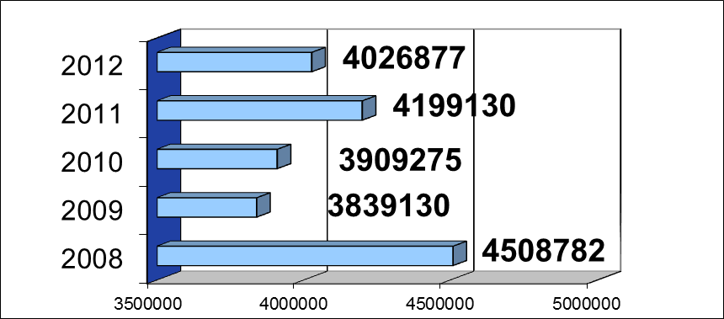

State budget allocated to the **PLA** (EUR)

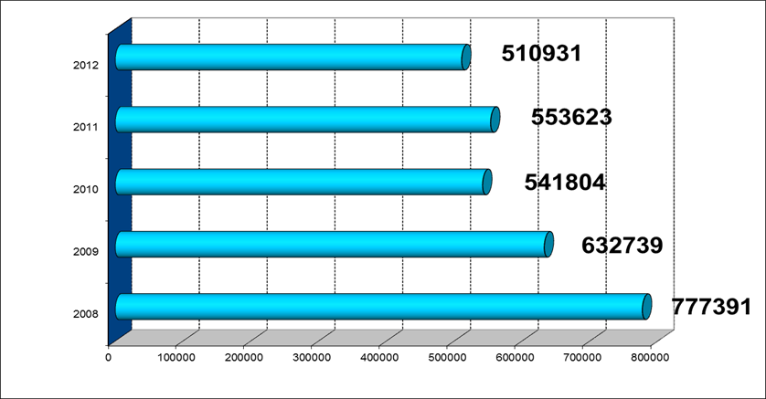

1. **Supervision**

Legal Aid Services, besides other:

* co-ordinate provision of PLA (analyses activities, submit proposals).
* coordinate provision of legal aid in criminal cases.
* control the provision of secondary legal aid (on the basis of agreements concluded with lawyers) .

Ministry of Justice: implements policy created by the Government, creates Drafts of the acts related to FLA and monitors implementation of existing Acts on FLA;

Coordination Council conducts analysis of the work of Municipalities and proposals for improvement of FLA. It consists of representatives of:

* the Committees on Legal Affairs and Human Rights of Lithuanian Parliament
* the Ministry of Justice
* the Ministry of Finance
* the Association of Local Authorities in Lithuania
* the Lithuanian Bar
* other institutions and associations whose activities are related to the provision of legal aid or to the protection of human rights

Lawyers’ Association of Lithuania controls the quality of FLA provided by lawyers.[31]

**II IMPLEMENTATION OF FREE LEGAL AID**

**Number of persons granted Primary Legal Aid**

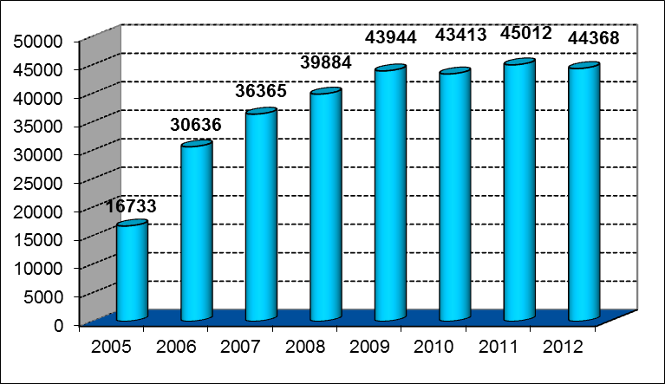

**Budget for Primary Legal Aid (EUR)**

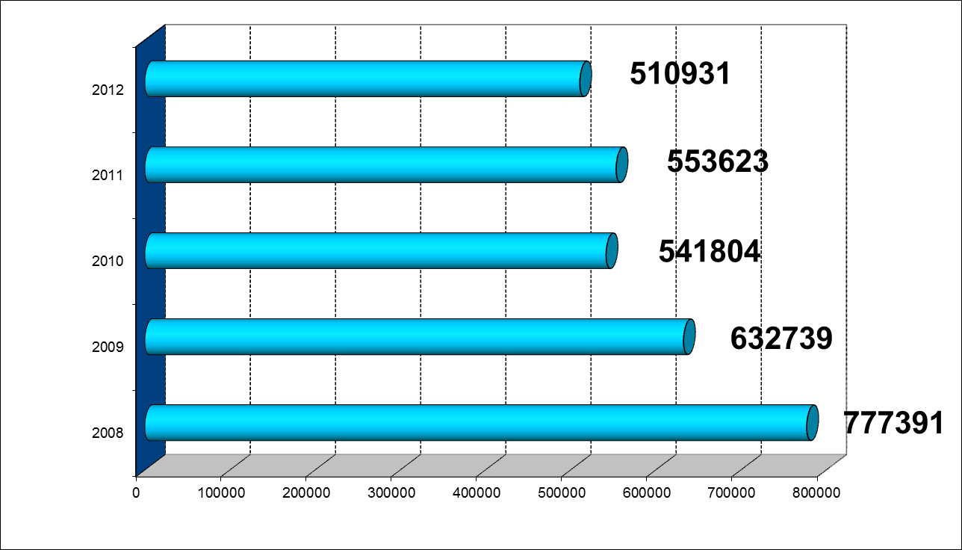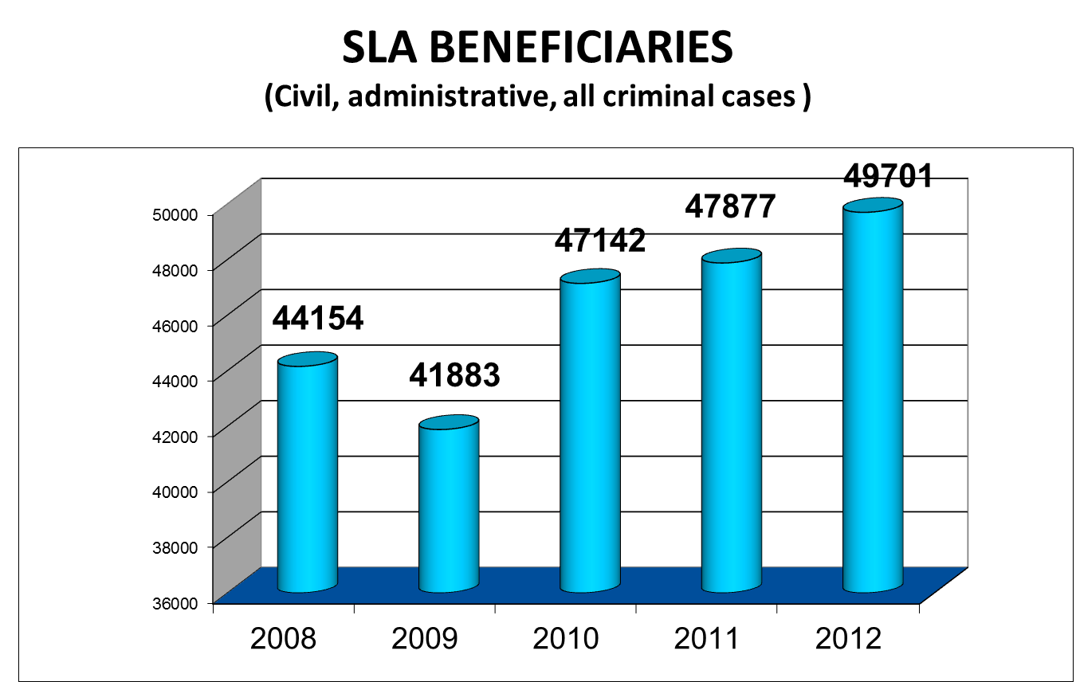

Number or cases when legal aid was granted by decision of the State-guaranteed legal aid service (civil, criminal and administrative cases) – 16536 cases:

* civil cases – 13595;
* administrative cases – 786;
* criminal cases – 2146;

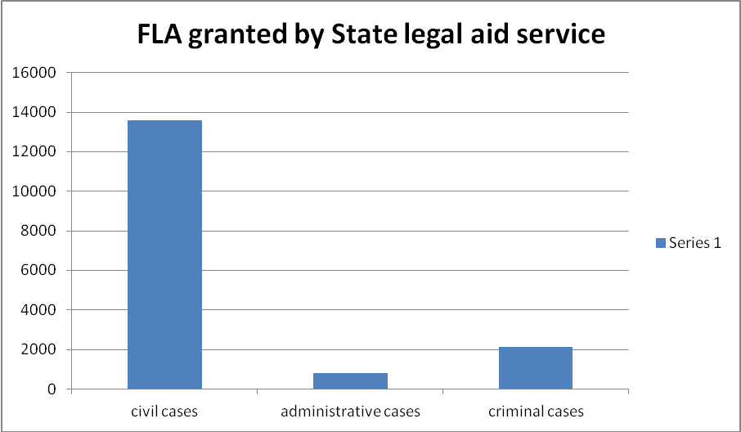

Number or cases when legal aid was granted by decision of a pre-trial investigation officer, prosecutor or the court (only criminal cases in which the presence of the defence lawyer is mandatory) – 33165 cases.

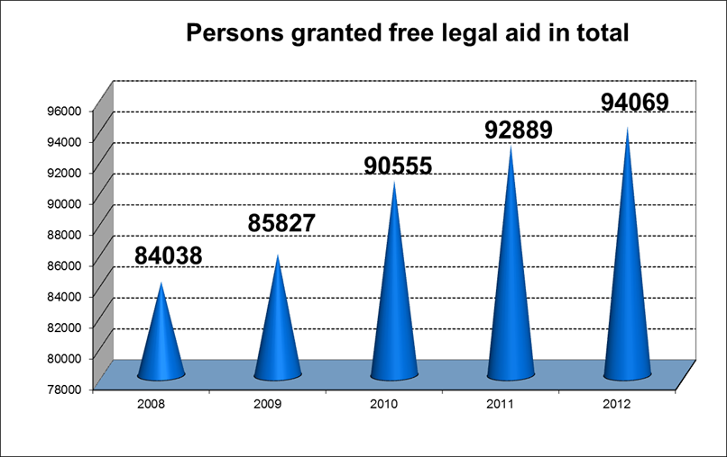

**BRCKO DISTRICT**

**I GENERAL INFORMATION ON FREE LEGAL AID LEGAL FRAMEWORK**

**Bosnia and Herzegovina has not enacted any comprehensive legislation that specifically regulates the provision of free legal aid to citizens**. However, there are a number of constitutional provisions and legislative enactments which govern or impact the provision of information and assistance services to citizens.

The Constitution of Bosnia and Herzegovina (Article II) provides that the rights and freedoms set forth in the European Convention for the Protection of Human Rights and Fundamental Freedoms (ECHR) and its Protocols are to apply directly in Bosnia and Herzegovina and are to **have priority** **over all other laws**. Article 6 of the ECHR guarantees the right to a fair trial. It also specifically secures the right to free legal aid in cases when a person who is charged with a criminal offence is unable to afford legal assistance and when this is required in the interest of justice. Over time, the case law of the European Court for Human Rights has also recognised the right to legal aid in civil cases. As a consequence, Bosnia and Herzegovina is under an obligation to provide free legal aid to its citizens in criminal, civil and other disputes involving “the determination of his civil rights and obligations”.

The constitutional obligation to provide legal aid has been further recognised in the **Justice Sector Reform Strategy** (JSRS) for BiH which has noted that*“[t]he lack of a comprehensive legal aid**system for criminal and civil cases must be rectified in order to ensure that economic status does**not inhibit the capacity of citizens to pursue their rights before the law.*”[32] The Strategy alsoidentifies several measures that would ensure creation of a harmonized system of free legal aid incivic, criminal and administrative cases across the country. Despite this strategic commitment,most of these measures have so far not been been implemented.

Regrettably**, a national framework law on free legal aid has so far not been adopted**. Although the country does not currently have a national law on legal aid, separate legal frameworks exist in its two constitutive entities Republika Srpska, the Federation of Bosnia and Herzegovina as well as in **Brcko District**, and several cantons in the second entity Federation BH adopted their own legislation on free legal aid.

The European Commission has emphasized the issue in its progress report on Bosnia and Herzegovina for 2012 and expressed the concern that “[t]he system of free legal aid in Bosnia and Herzegovina remains fragmented and unregulated in some Cantons of the Federation” and noted that the Framework Law on Free Legal Aid had not yet been adopted.[33]

In its progress report on Bosnia and Herzegovina for 2013, European Commission repeated “Concerning access to justice in civil and administrative trials, wide access to the web-based free legal aid providers’ network has been provided. Free legal aid offices have been set up in three more Cantons of the Federation, bringing the total to seven. The system of free legal aid remains fragmented and unregulated in three Cantons. The adoption of a State-level Law on Free Legal Aid remains pending. Free legal aid in civil cases continues to be provided, mainly by privately-funded NGOs. Free legal aid in administrative cases remains insufficient.”[34] In the Brcko District, which has 87,332 inhabitants situation is most favorable, where free legal aid is regulated and fully established 2002nd since when function smoothly.

At the level of the Brcko District of Bosnia and Herzegovina was adopted the Law on the Legal Aid Office Brcko District of Bosnia and Herzegovina, which established the Legal Aid Office of Brcko District (hereinafter "the Office of BD"), with the aim of providing legal assistance to indigent citizens in certain proceedings in the District. The law was passed because the arbitrary decision of 5th March, 1999. year , which established Brcko District of Bosnia and Herzegovina as a single administrative unit of local government under the sovereignty of Bosnia and Herzegovina, the Arbitration Tribunal explicitly predicted, among other things, reform of the judiciary, which includes the establishment of justice District, consisting of the Judicial Commission, Appellate Court, Basic Court, Public Prosecutor's Office and the Legal Aid Office. BD's Office provides legal advice and represent the citizens of the District indigent in the District, in front of the Basic Court of Brcko District of BiH, the Appellate Court of Brcko District of BiH and the Brcko District Prosecution Office.

1. **Beneficiaries**

FLA is limited only to the proceedings **before the institutions of the District**.[35]

In Brcko District FLA is being provided to the citizens of the District with low income exclusively. The Law on Office for legal aid of Brcko District excludes citizens with residence outside of the District from being eligible for FLA. It is absurd to have them excluded, although they may have obvious legal interest and fulfill all other criteria. At the same time despite the fact that problems related to status of refugees, IDPs and returnees are numerous, these categories are not recognized as free legal aid beneficiaries.

BD Office provides free legal assistance to customers who meet the cumulative conditions and that they do not have enough money for a lawyer and the costs of legal representation and meet the financial criteria for representation. The right to legal assistance of financial criteria are : ( 1 ) persons who receive social assistance, ( 2 ) unemployed with no regular income or other income, (3 ) a person who is indigent, ( 4 ) children without parental care, ( 5 ) a person of bad health condition with no income.

The basis for determining the right to legal aid for indigent includes total income and assets that are not considered as income, and that the applicant and members of the family do not pay taxes. When determining the right to legal aid based on financial criteria do not take into account the income and assets of family members of those who are opposing party claimant.

District law provides that no person is considered indigent is a person who lives in the same household with an adult member of his family, and that is such a financial state that is able to bear the costs of legal services to persons with him living in the same household.

1. **The procedure for the approving of free legal aid**

In the Brcko District request for eligibility for legal aid shall be submitted to the President of the Basic Court of Brcko District of Bosnia and Herzegovina, with the attached evidence of meeting the financial criteria for representation in all procedures that are seeking representation without compensation, except the mandatory defense in criminal cases.

Decision on engagement of the Office for representing in the criminal proceeding before the Prosecutor’s Office or the Court is being made by the **President of the Basic Court, a judge or the panel**, in accordance with the Law on Criminal Procedure of Brcko District BiH, whereas such a decision for civil and other cases is being made by the **President of the Basic Court** in accordance with the procedure prescribed by the law or special regulation.

**Director of the Office is** making a decision on providing legal aid in administrative cases, upon a request of the party.

Against the decision of the President and the Director of the Office rejecting the application for legal aid, the applicant has the right to appeal within 15 days to the Judicial Commission.

1. **Types of FLA**

Law on Office for legal aid makes no distinction between primary and secondary legal aid. Article 10 defines following types of legal aid to be obtained:

* oral advices on all rights and obligations;
* assistance in completing forms;
* legal assistance in completing all kinds of writings;
* representation before the administrative body;
* representation before the court;
* drafting the appeal;
* legal assistance in mediation.

1. **Eligible procedure/matters for granting FLA**

The Office represents indigent citizens in the following cases/proceedings:

* criminal
* civil
* non-contentious
* enforcement
* misdemeanor
* administrative
* other cases, as prescribed by the law.

The Office also provides verbal legal counseling **on all rights and obligations**, assists in filling in the forms and provides legal assistance in filling in all writs.

1. **FLA providers**

Due to it’s exceptional status within Bosnia and Herzegovina and it’s limited number of citizens it has a **centralized FLA system**, which is being provided by the **Legal Aid Office of Brcko District BiH** established in accordance to the Law passed in 2007.

Legal Aid Office of Brcko District BiH, pursuant to the Section V in the Statute of Brcko District BiH, is an **independent institution** tasked with providing legal counseling and representing indigent citizens of Brcko District BiH in litigations and criminal proceedings.

BD office is located in the building of the Court of Brcko District and is transparent to all users of free legal aid. As part of the judiciary district, it has the same spatial and material conditions as well as other judicial authorities and the prosecution and the courts.

Competencies of the Office have been prescribed in the Article 7 of the Law on Legal Aid Office, which states that the Office is responsible for providing legal counseling and representing indigent citizens of Brcko District BiH, as well as for undertaking all actions before the Brcko District of BiH Basic Court, Brcko District Appellate Court and Prosecutor’s Office of Brcko District. The Office is undertaking all actions and participates in all phases of the proceedings until final termination of the case.

Office has **11 full-time employees**. 6 of them (Director and 5 lawyers) provide free legal aid.

* **Trainings for providers in Brcko District**

In order to improve the quality of services provided by the Legal Aid Office, as well as continuous monitoring of new regulations and modification of existing ones and monitoring of case law, legal representative of the Office continuously improves professionally by attending seminars in different areas of law .

Attorneys have attended seminars organized by the Center for Education of RS and FBiH and Brcko District Judicial Commission in Criminal and Civil Matters .

To keep up with this program orientation, in order to improve the quality of services provided by the Office, as well as continuous monitoring of the new amendments to the existing regulations and monitoring of case law, legal representatives will attend compulsory education in criminal justice and civic consultations organized by the Judicial Commission of Brcko District, Bosnia and Hertzegovina and the Centers for Education of RS. In addition to further educate, they will also attend the seminars organized specifically for providers of free legal aid, and other appropriate seminars.

             In a short time the attorneys of the Legal Aid Office will be able to access the database of all providers of legal aid, which are part of the Network of Providers of Free Legal Aid (Center for Legal Assistance of the Republic of Serbian, the Cantonal Institute for Legal Assistance Tuzla, Cantonal Office of Legal Aid Zenica, the County Office of Legal Aid Odžak, County Office of Legal Aid Siroki Brijeg, Human Rights Centre Mostar, Your Rights Association BiH). This will have major influence on improving the quality of services provided by the Office.

1. **Funding**

District provides necessary financial and any other support in order to ensure undisrupted and regular Office functioning. The Office is clearly mentioned and presented share of the budget within the District budget. In the procedure of budget preparation and adoption, Office Director submits the Office budget draft to the Judicial Commission for the sake of determining the final budget draft of the Office. Director is responsible for execution of the Office budget.

|  |  |
| --- | --- |
| **Funding of the Legal Aid Office Brcko District of BiH - amount in euro[36]** | |
| Gross wages and benefits | 216,895.18 |
| Allowances for employees and Parliamentary representative | 2,045.19 |
| Employer contributions | 8,675.80 |
| Travel expenses | 1,022.59 |
| Expenses for utilities | 3,067.79 |
| Procurement of materials and small tools | 3,323.44 |
| Expenses for transportation services and fuel | 766.94 |
| Expenditures for maintenance | 1,533.89 |
| Expenses for insurance, banking services and payment services | 1,022.59 |
| Contractual services | 2,556.49 |
| Procurement of equipment | 10,225.99 |
| **Total** | **251,135.97** |

|  |  |  |  |  |
| --- | --- | --- | --- | --- |
| **Funding of the Legal Aid Office Brcko District of BiH - amount in euro[37]** | | | | |
|  | Monthly gross salary | Period of engagement | Number of employees | Total resources |
| Director | 2,749.23 | 12 | 1 | 32,990.79 |
| Lawyer | 2,320.48 | 12 | 5 | 139,228.96 |
| Head of administration | 1,035.81 | 12 | 1 | 12,429.79 |
| An investigator | 729.11 | 12 | 1 | 8,749.36 |
| Secretary – assistant | 713.26 | 12 | 1 | 8,559.15 |
| Operator – assistant | 649.86 | 12 | 1 | 7,798.34 |
| Letter messanger – the driver - janitor | 530.98 | 12 | 1 | 6,371.81 |
| Salary supplement | 0.00 | - | - | 766.94 |
| Contributions paid by employers | 0.00 | 12 | - | 8,675.80 |
| Total |  | | | 225,570.68 |

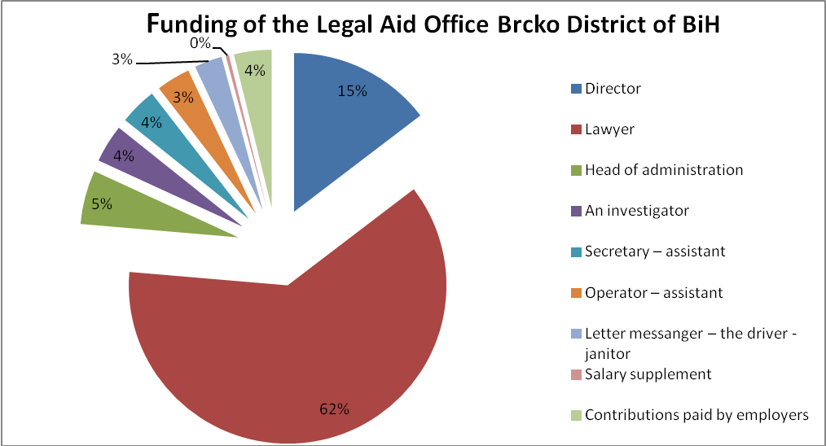

1. **Supervision**

According to the Article 47 of the Law on Office for legal aid[38] prescribes that the Office for FLA reports to the **Judicial Commission**, which evaluates it and gives suggestions without undermining the independence of the institution of the Office for FLA. This report may be afterwards sent before the Parliament of the District.

**II IMPLEMENTATION OF FREE LEGAL AID**

During the reporting period (01.01. – 31.12.2012. 2012) the Office has 1685 active cases:

* criminal 321
* civil 388
* non-contentious 51
* enforcement 78
* cases of the Panel for Display[39] 752
* misdemeanor 95

Chart 1 – Active cases in 2012

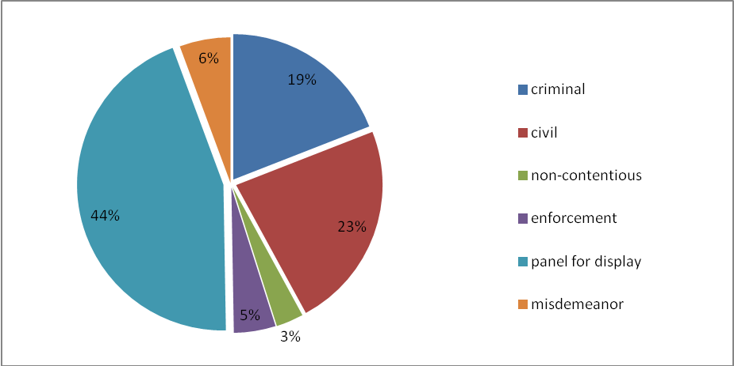

Chart 2 – Cases opened during 2012.

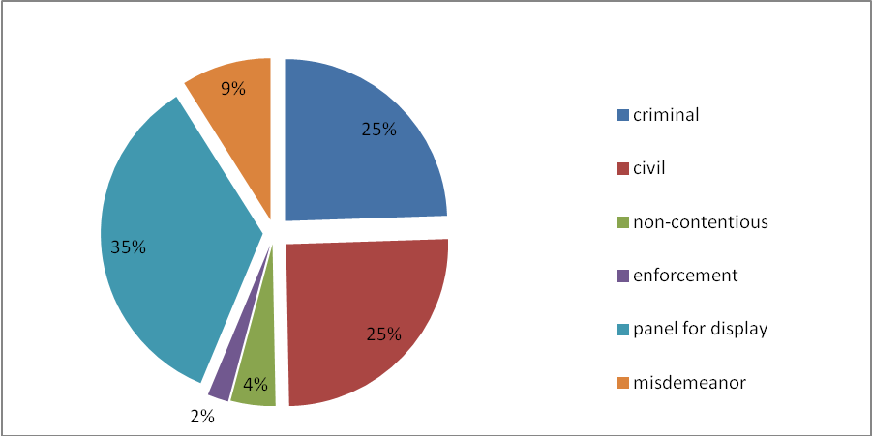

***Table 1 – Report on number of cases***

|  |  |  |  |  |
| --- | --- | --- | --- | --- |
|  | **Backlog from previous years** | **Cases opened during 2012.** | **Active cases during 2012.** | **Cases closed during 2012.** |
| Criminal cases | 157 | 164 | 321 | 131 |
| Misdemeanor | 35 | 60 | 95 | 61 |
| Civil cases | 219 | 169 | 388 | 138 |
| Non-contentious | 21 | 30 | 51 | 27 |
| Enforcement cases | 64 | 14 | 78 | 21 |
| Panel for Display | 519 | 233 | 752 | 226 |
| TOTAL | 1.015 | 670 | 1.685 | 604 |
| Verbal counseling |  | | 2.488 |  |

During the period January 01 – December 31, 2012 the Office received 164 new criminal cases, in addition to another 157 backlogged cases. In the above-mention period, the Office had a total of 321 active criminal cases.

131 cases were closed during 2012.

The Office represented clients in 388 cases, 169 of which have been started during the year 2012 and the remaining 219 were backlogged cases.

138 cases were closed during 2012.

|  |  |  |
| --- | --- | --- |
| **Legal basis** | **Representation in cases started in 2012** | **Representation in backlogged cases** |
| division of of marital property | 5 | 8 |
| alimony | 1 | 9 |
| change of child custody decision | 5 | 3 |
| child custody | 10 | 5 |
| divorce | 21 | 16 |
| divorce with child custody | 19 | 8 |
| divorce with child custody and alimony | 21 | 15 |
| divorce with spousal support |  | 4 |
| annulment of marriage | 1 |  |
| determining marital property | 4 | 8 |
| paternity | 6 | 3 |
| handing over possession of the property | 1 | 6 |
| recognition of property rights |  | 11 |
| affirmation | 2 | 5 |
| regulating land dispute |  | 2 |
| usage crossing the property | 1 | 5 |
| trespass | 2 | 5 |
| gaining no basis | 2 | 3 |
| contract termination | 1 | 5 |
| recall of the deed of gift | 1 |  |
| compensation for damage | 10 | 13 |
| the return of property or payment | 1 | 2 |
| payment |  | 5 |
| debt | 44 | 64 |
| collection of claims | 2 |  |
| enforcement of action |  | 1 |
| eviction |  | 1 |
| labor dispute | 6 | 3 |
| denial a necessary part of succession |  | 2 |
| annulment of the decision | 3 | 7 |
|  | **169** | **219** |

* **MISDEMEANOR**

During the reporting period the Office represented clients in 95 misdemeanor cases. 60 such cases were started during 2012, and there were also 35 backlogged cases form previous years.

61misdemeanor cases were closed during 2012.

* **NON-CONTENTIOUS CASES**

During the reporting period the Office represented clients in 51 non-contentious cases. 30 such cases were started during 2012, and there were also 21 backlogged cases form previous years.

27 non-contentious cases were closed during 2012.

* **ENFORCEMENT CASES**

During the reporting period the Office represented clients in 78 enforcement cases. 14 such cases were started during 2012, and there were also 64 backlogged cases form previous years.

21 enforcement cases were closed during 2012.

* **PANEL FOR DISPLAY OF PROPERTY DATA CASES**

At the time when the Panel for Display of Property Data started working, the Office was engaged pursuant to the Article 233, paragraph 1 in the Law on Land Registry and Property Rights of Brcko District BiH, because persons whose address of permanent or temporary residence is unknown and when such persons do not report to the Court for the purposes of participation in the process, they are awarded an Office lawyer to temporary represent them. During 2012 the Office was engaged in **752 cases**, 233 of which were started in 2012 and remaining 519 in previous years.

226 cases related to the Panel for Display of Property Data was finalized during 2012.

* **VERBAL COUNSELING**

During 2012, lawyers of the Office have provided **2,488 verbal advices**. Most of those were related to property issues, signing a contract, divorces, division of property acquired during marriage, alimony, inheritance-related problems, trespassing, complaints to the enforcement decisions, as well as to issues related to all other areas of law.

**Office lawyers appeared before the court 1.584 times. Average number of working days per year is 250, which means that lawyers had approximately 6.3 court appearances and average of 9.9 verbal counseling cases per day.**

**COMPARATIVE OVERVIEW**

|  |  |  |  |  |  |  |  |
| --- | --- | --- | --- | --- | --- | --- | --- |
| Country/entity | Population[40] | Number of FLA beneficiaries in 2012[41] | Number of cases to which FLA was granted in 2012[42] | Annual public budget allocation to FLA system in 2012 in euros[43] | Annual FLA budget per inhabitant in 2012 in euros | Annual public budget per case to which FLA was granted in euros | GDP per capita in euros[44] |
| Croatia | 4 456 096 | 5875 | 5 877/5970[45] | 167 365.26 | 0.04 | 28.48 | 10 688.38 |
| District of Brcko | 103 240 | NA | 1 685 | 240 906.42 | 2.33 | 142.97 | 3 508.12 |
| Lithuania | 3 043 429 | 94096 | 49 701 | 3 906 105.00 | 1.28 | 236.22 | 10 920.92 |
| Montenegro | 625 266 | 367 | 304 | 15 570.00 | 0.03 | 51.21 | 5 421.58 |
| Slovenia | 2 055 496 | NA | 8 380 | 6 562 466.95 | 3.19 | 783.11 | 16 940.02 |

**CONCLUSIONS / SUMMARY**

By comparison of the results of the analysis of free legal aid systems, following conclusions could be drawn:

First, in countries where FLA system has been functioned for many years, there is a tendency of budget cuts for FLA (Slovenia , Lithuania). This trend is likely caused by saving measures, since the reduction of the budget is not accompanied by a reduction in demand for FLA ​​.

Second, countries with higher GDP alocates more money per case. Thus, Slovenia stands out even 783 euros per case, while Lithuania allocates less. However, it was not accompanied by a large number of requests in Slovenia, while Lithuania has the highest number of requests that is caused by visibility of clearly developed system.

Third, registration of providers of primary legal aid affects the increasing visibility of secondary legal aid that becomes accessible for relevant beneficiaries (Lithuania, Croatia).

Fourth, states that have established FLA system lately have not provided sufficient funds for it’s functioning. From the examined countries, Montenegro invests the least sources for the functioning of FLA system. Law has reserved the right to provide FLA only for lawyers and has predicted that courts decide on granting FLA. Associates in court are doing administrative tasks. A very small number of requests have been received in the first year of implementation of Law on FLA. The system of free legal aid is not enough visible to potential beneficiaries. The Law on FLA does not introduce new system in comparison to the system that existed before the enactment of the Law, which through procedural laws provided right to free legal aid on the basis of indigent right. There is no registration of lawyers by specialty, which reduces quality assurance.

Fifth, organization of the state Office for FLA that employ lawyers (Brcko) as permanent staff is most cost effective system when it comes to organization of secondary legal aid. It provides quality control and supervision of the work of lawyers. On the other hand, it calls into question the fundamentals of the legal profession as freelancers, and when it comes to Serbia, this system is not in accordance with the Code of Professional Ethics for Lawyers .

**Basic recommendations**

* First, FLA system should predict a larger number of providers with different funding schemes. In this way, among providers competition is increased and free legal aid system is becoming more apparent to beneficiaries.
* Second, FLA system should clearly predict cascade system of consulting (legal information, legal advice, representation). In this way, it is possible to reduce the number of potential disputes.
* Third, FLA system with the prediction of different types of providers, ensures the quality through emphasizing the specialty of various providers .

1. European Commission, “Montenegro 2012 Progress Report. Enlargement Strategy and Main Challenges

   2012-2013” SWD(2012) 331 final, Brussels, 10 October 2012:

   <http://ec.europa.eu/enlargement/pdf/key_documents/2012/package/mn_rapport_2012_en.pdf>
2. European Commission, “Montenegro 2013 Progress Report. Enlargement Strategy and Main Challenges

   2013-2014” SWD(2012) 411 final, Brussels, 16 October 2012:

   <http://ec.europa.eu/enlargement/pdf/key_documents/2013/package/mn_rapport_2013.pdf>
3. Submission by the United Nations High Commissioner for Refugees - For the Office of the High Commissioner for Human Rights’ Compilation Report - Universal Periodic Review: MONTENEGRO. <http://www.refworld.org/docid/4ffd355f2.html>
4. Art. 1, Law on Free legal aid, Official Gazette of Republic of Montenegro No. 23-3/11-2/13, EPA 486 XXIV.
5. Izveštaj o radu i stanju u upravnim oblastima iz Nadležnosti Ministarstva rada i socijalnog stanovanja Crne Gore – 19.03.2013. godine, 42 strana (Tabela 1.1, 1.2)
6. Legal Aid Offices - further in the text – Office.
7. Round tables are organized with the financial support from United Nations Development Programme (UNDP) Office in Montenegro, the Organization for Security and Cooperation in Europe (OSCE) - Mission to Montenegro and the Human Resources Administration of Montenegro.
8. According to the response of the Secretariat of the Judicial Council for the cost of free legal aid, pursuant to the Law on Free Legal Aid, in a letter SU.R.no.1/14 dated on January 23rd 2014.
9. During monitoring CEDEM came to the conclusion that these courtrooms were never marked as Offices for Free Legal Aid. Based on the interviews that YUCOM conducted with advisor Ana Radunović from Basic Court in Berane we got the information that the Office for FLA was equipped with the support of Bar Chamber of Montenegro.
10. <http://www.pravda.gov.me/rubrike/Sektor-pravosuda/133794/Ministartvo-pravde-daje-na-raspravu-Nacrt-Strategije-reforme-pravosuda-2014-2018.html>
11. Free Legal Aid Act (OG [62/08](http://narodne-novine.nn.hr/clanci/sluzbeni/2008_05_62_2098.html), [44/11](http://narodne-novine.nn.hr/clanci/sluzbeni/2011_04_44_1043.html)– Decision and Order of the Constitutional Court of the RoC and [81/11](http://narodne-novine.nn.hr/clanci/sluzbeni/2011_07_81_1721.html)).
12. European Commission, Croatia 2011 Progress Report, Brussels, 12.10.2011, SEC(2011) 1200 final , page 50
13. European Commission, Comprehensive monitoring Report on Croatia’s state of preparedness for EU Membership, Brussels, 10.10.2012 SWD(2012) 338 final, page 37
14. See: http://www.pravosudje.hr/beneficiaries-of-free-legal-aid-
15. <http://www.mprh.hr/beneficiaries-of-free-legal-aid->
16. Law Faculty in Split and Law faculty in Zagreb.
17. *Report on the approving right to legal aid and the expenditure of funds 2012.*
18. According to the archive of National bank of Croatia, middle exchange rate on date December 31th 2012 7,564 <http://www.hnb.hr/tecajn/h310112.htm>
19. YUCOM got the Report from Ministry of Justice of Croatia upon Free Access to Information Request submited on November 26th, 2013.
20. Reserved amount is amount that is expected to be paid in the period between 2013-2015 since the realization of payment for lawyers comes after finalization of proces.
21. According to the archive of National bank of Croatia, middle exchange rate on date December 31th 2012 7,564 <http://www.hnb.hr/tecajn/h310112.htm>
22. **Free Legal Aid Act –**Zakon o brezplačni pravni pomoči**(Official Gazette of the Republic of Slovenia**48/2001, 50/2004, 96/2004-UPB1, 23/2008)
23. Human Rights Council, Working Group on the Universal Periodic Review, Seventh session , Summary prepared by the Office of the High Commissioner for Human Rights, in accordance with paragraph 15 (c) of the Annex to Human Rights Council Resolution 5/1, Geneva, 8-19 February 2010
24. Bureau of Democracy, Human Rights and Labor, United States Department of State, *2011 Country Reports on Human Rights Practices - Slovenia*, 24 May 2012, available at: http://www.refworld.org/docid/4fc75a623a.html [accessed 8 January 2014], UNHCR
25. **Free Legal Aid Act –**Zakon o brezplačni pravni pomoči**(*Official Gazette of the Republic of Slovenia***48/2001, 50/2004, 96/2004-UPB1, 23/2008)
26. Official response of Ministry of Justice of Republic of Slovenia to our Free access to information request sent.
27. ibid
28. Judicial Statistics for 2012 of Ministry of Justice of Republic of Slovenia (Sodna Statistika 2012) <http://www.mp.gov.si/fileadmin/mp.gov.si/pageuploads/mp.gov.si/PDF/Sodna_statistika/SodnaStatistika_2012.pdf>
29. <http://www.mp.gov.si/fileadmin/mp.gov.si/pageuploads/mp.gov.si/PDF/Sodna_statistika/SodnaStatistika_2012.pdf>
30. Official Gazette 2000, No 30-827; 2001, No 71-2521; 2003, No 38-1722, No 123-5584.
31. Free Legal Aid System in the Republic Of Lithuania, ppt made jointly by Ministry of Justice of Republic of Croatia, Kaunas Service of legal aid guaranteed by the State of the Republic of Lithuania and the Ministry of Justice of the Republic of Lithuania
32. Ministry of Justice, “The Justice Sector Reform Strategy of Bosnia and Herzegovina” 2008, accessible online:

    http://www.mpr.gov.ba/dokumenti/projekti/Default.aspx?id=913
33. European Commission, “Bosnia and Herzegovina 2012 Progress Report. Enlargement Strategy and Main Challenges 2012-2013” SWD(2012) 335 final, Brussels, 10 October 2012, p.16:

    http://ec.europa.eu/enlargement/pdf/key_documents/2012/package/ba_rapport_2012_en.pdf.
34. European Commission, “Bosnia and Herzegovina 2013 Progress Report. Enlargement Strategy and Main Challenges 2013-2014” SWD(2013) 415 final, Brussels, 16 October 2013, p.13:

    <http://ec.europa.eu/enlargement/pdf/key_documents/2013/package/ba_rapport_2013.pdf>
35. <http://www.kppbd.ba/>
36. According to the official exchange rate of the Central Bank of BiH on date 31.12.2012.
37. According to the official exchange rate of the Central Bank of BiH on date 31.12.2012.
38. Law on Office for legal aid No.19/07 <http://skupstinabd.ba/ba/zakoni/ba/zakon-o-kancelariji-za-pravnu-pomo.html>
39. Panel for Display of Data on Real Estate
40. Last available data on population, respectively: Croatia: <http://www.dzs.hr/> (2011); District of Brcko: http://www.bhas.ba/publikacijebd/2010/Demografija%20za%202010%20DB.pdf (2010); Lithuania: <http://osp.stat.gov.lt/en/2011-m.-surasymas> (March 2011); Montenegro: <http://www.monstat.org/userfiles/file/popis2011/saopstenje/saopstenje.pdf> (2011); Slovenia: <http://pxweb.stat.si/pxweb/Dialog/Saveshow.asp> (2012)
41. Respectively: Croatia: Report on realization of the right on free legal aid and utilization of funds in 2012, Ministry of Justice (Izvješće o ostvarivanju prava na besplatnu pravnu pomoć i utrošku sredstava u 2012. godini); District of Brcko: Report on work of Office for legal aid of District of Brcko BH in period 01.01 – 12.31.2012, No Ku-47/13, issued on March 7th 2013 (Izvještaj o radu Kancelarije za pravnu pomoć Brčko distrikta BiH za period 01.01. - 31.12.2012. godine); Lithuania: ; Montenegro: Research of FLA system in Montenegro – creation of effective and sustainable FLA system conducted jointly by Center for Democracy and Human Rights and Civic Alliance with support of UNDP Office in Montenegro, September 2013 (Istraživanje sistema besplatne pravne pomoći u Crnoj Gori – kreiranje efektivnog i održivog sistema pružanja besplatne pravne pomoći); Slovenia: Judicial Statistics of Ministry of Justice of Republic of Slovenia (Sodna statistika 2012 ISSN 1318-4326)
42. ibid
43. ibid
44. GDP per capita source: <http://data.worldbank.org/indicator/NY.GDP.PCAP.C> ; US dollar to Euro average exchange rate in 2012 source: <http://www.ecb.europa.eu/stats/exchange/eurofxref/html/eurofxref-graph-usd.en.html>
45. Official Report on realization of the right on free legal aid and utilization of funds in 2012 of Ministry of Justice of Republic of Croatia stated 5 877. Yet, in response to our Free access to Information request Ministry stated that 5970 was the number of cases to which FLA was granted in 2012. In further calculations number from Official report was used.