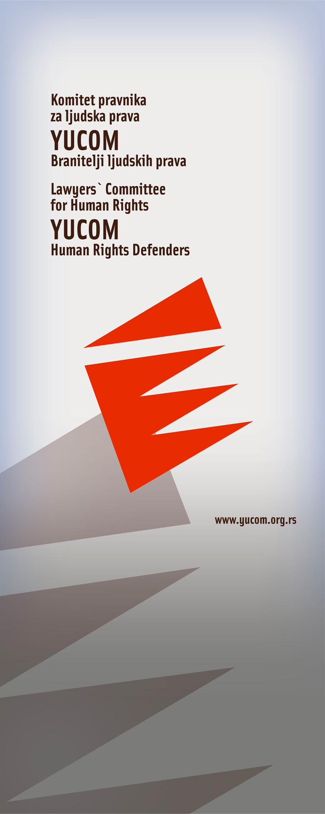

LEGAL AID OFFICE BULLETIN
May 2011

Lawyers’ Committee for Human Rights
Svetogorska 17
11 000 Beograd

Call center for providing legal aid
0 700 400 700



Bulletin of the project “Legal aid in cases of violation of human Rights, discrimination and protection of human rights defenders”, implemented by YUCOM with the support and the cooperation of the non governmental organization Civil Rights Defenders

Domestic violence

I.D. from Belgrade addressed Lawyers’ Committee for Human Rights, asking for help in order to initiate proceedings for divorce, and protection from domestic violence. Primarily, I.D. addressed the competent legal assistance in the municipality, but the court refused to act upon such claim. Lawyers Committee for Human Rights took the case into procedure, made a new complaint and filed a new complaint, subsequently initiating the procedure shortly before the competent court.

Since the I.D. was a victim of domestic violence by her husband, together with filing of the complaint, it was asked for determining the measure of protection from domestic violence. The court proceedings ended in just two hearings, which has been contributed mostly by good cooperation and coordination of the competent Center for Social Work and the Court.

This case represents one of the positive examples of good practices of relevant institutions in enabling citizens to exercise their rights and to protect them through regular channels.

Also, this is an indicator that is still possible to implement the existing legal provisions and the available mechanisms of protection adequately, particularly in the areas of family law protection, where such acting, although most essential, is often the exception rather than the rule.

The right to a fair trial (trial within a reasonable time)

V.B. from Belgrade began a labor dispute as far back as 1999, before the Third Municipal Court in Belgrade. The first instance Court’s Decision was brought in 2009, then ten years after the initiation of proceedings.

In June 2009, dissatisfied with the decision of the court, she appealed to the District Court in Belgrade, which was after the judicial reform, submitted to be acted upon at the Court of Appeal. In October 2010 she personally submitted urgent letter in which she was asking for her case to be taken into procedure, given the duration of the trial.

Since no decision has been made by the urgency and she did not receive any reply, she addressed the Committee of Lawyers for Human Rights in late May 2011. YUCOM sent an urgent letter to the Appellate Court in Belgrade, asking it to act upon her case regardless of its place in order, bearing in mind that it has been acting upon the appeal for three years, and especially noting
the duration of trial. After a while V. B., after three years, received a decision on the appeal.

In contrast to the first described case, this is a situation in which we have repeatedly pointed out in previous newsletters - violation of the right to a fair trial, in part which relates to a trial within a reasonable time. It is especially indicative that this is a labor dispute case, which under the applicable legal provisions includes the urgency of treatment.

Abuse of power

J.D. from Belgrade, the high school student, addressed Lawyers Committee for Human Rights with complaints about the work of a member of PS Savski Venac. According to her allegations, in March 2011 the named police officer came to her address without a search warrant or any document, in plain clothes, on the grounds that it is necessary to give him information about a fight at school, which she supposedly witnessed.

However, during the questioning this issue - the fight was not touched upon at any point-there was no word of it, and conversation all the time amounted to a trial on drug use and the human trafficking and even intimate details from her sex life.

On the same occasion, she was presented several photos of her, several of which are located on her facebook profile - which is normally closed, so access to photos is allowed only to friends to whom she granted it. One of the photographs was from her identity card, and she was also showed a photo of a boyfriend with whom at that time was in a relationship.

The next day, came the invitation to report to the PS Stari Grad, on offense from Article 246 CC RS.

D.J. responded to the call a week later, in the presence of a lawyer.

At the end of the conversation, when leaving the station, he turned to her with words: "Greetings and see you!", Then, asked by a lawyer, "where they wikk see each other," replied that "you never know." According to her, this encounter happened, in a Belgrade park two weeks after the interview.
We note that during the first visit to her apartment above mentioned policeman asked for her phone number, and the very next day called her multiple times.

In the same period, the above mentioned police officer went to the "questioning" (also in civilian clothes and without any order) with her close friends, her current partner and the girl D.J. should have started to live with.

On the occasion of this event, YUCOM made a complaint against the mentioned official to the Ministry of Interior - Department of Internal Affairs, arguing that he had overstepped his legal authority, hurting her right to respect of private and family life, inviolability of home and personal data. On the same basis, a complaint was sent to the Commissioner for Information of Public Interest and the Protection of Personal Data.

By supporting the efforts and commitment of police officers in solving crimes, however, we draw attention to the obligation to in their work police officers must abide by legal authority - rather than to abuse the same at the expense of citizens - and thus further enhances the already long-held distrust of citizens in those who would supposed to protect them.

